

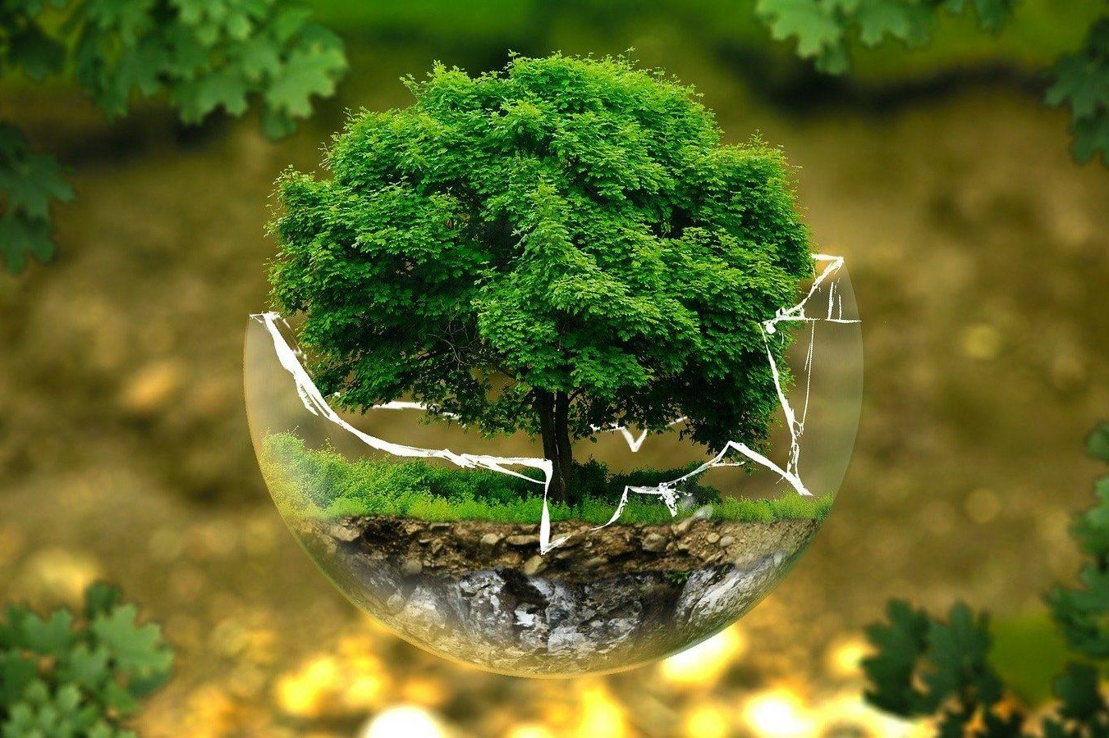

GS3: Environment

June 2025

### Prepared together by:

#### Madhav Agarwal (<https://t.me/madhavagrawalair16>)

#### Ratnesh Agrrwal (Insta: <https://www.instagram.com/ratnesh13/>)

**Disclaimer:** These notes are for guidance & reference only, based on our study, experience, & memory. Some fun mnemonics/terms may be included just to aid recall—no offence is intended. Please use your judgment and keep them updated over time.

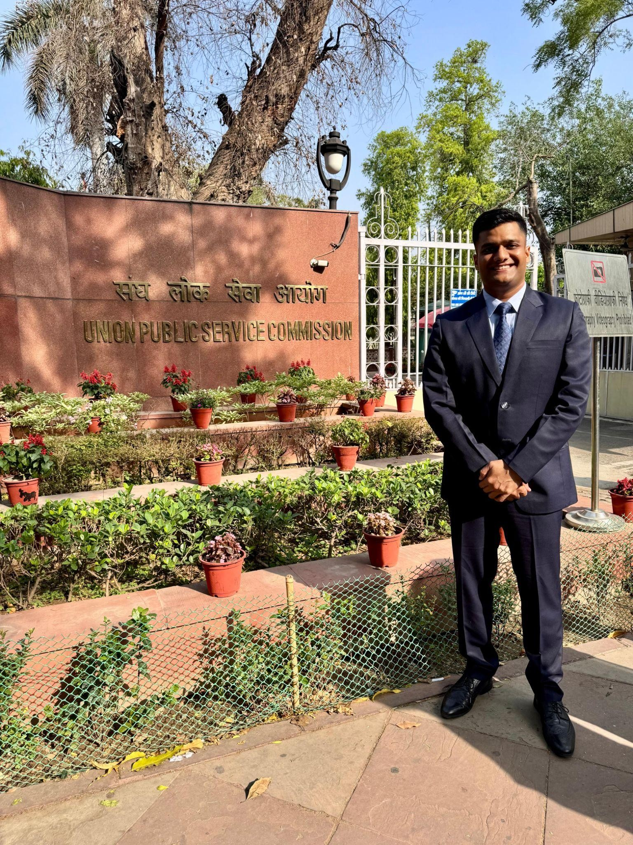**About Us**

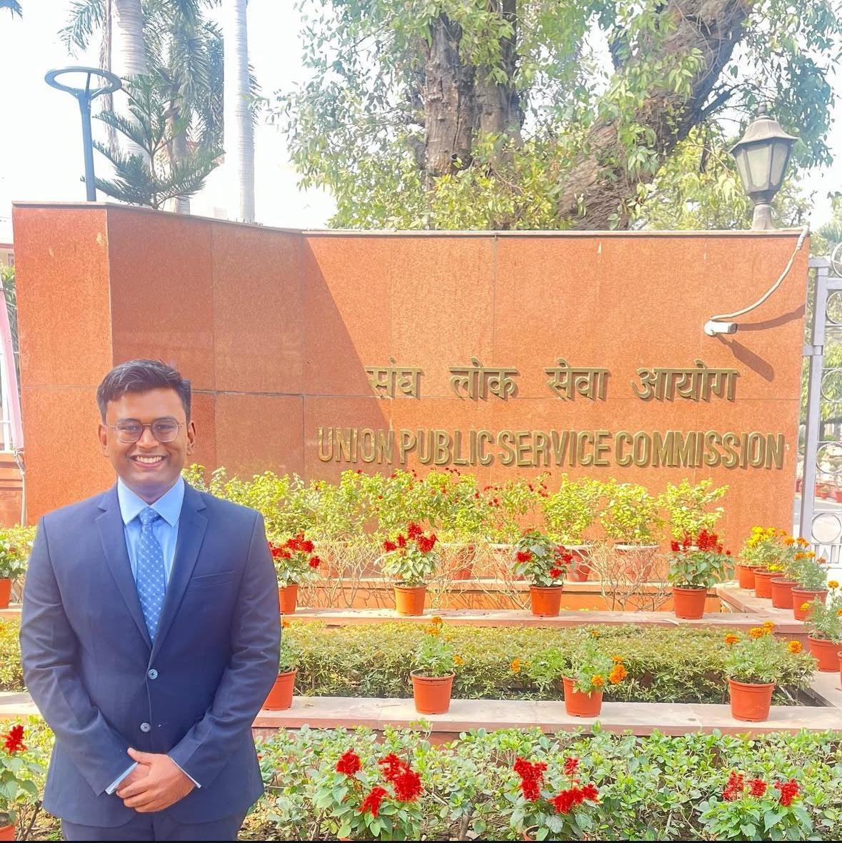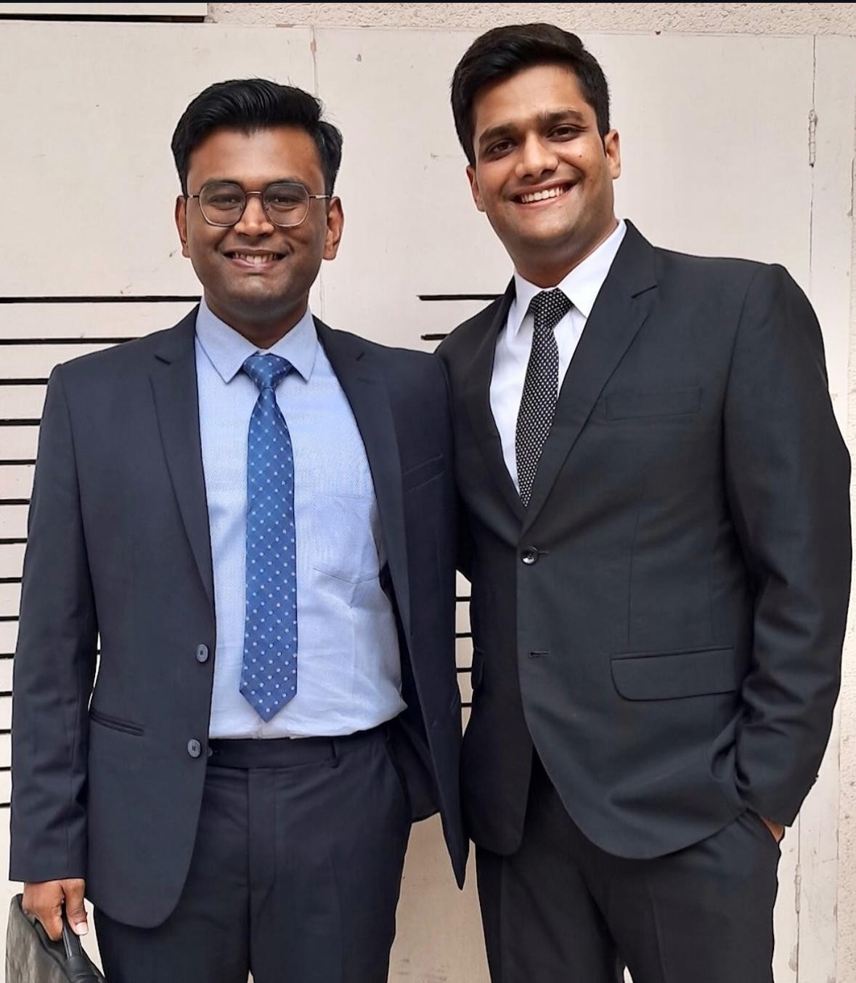

***Madhav Agarwal and Ratnesh Agrawal*** *— two friends, one mission, and a bond forged through shared dreams. From school classrooms to college corridors, their journey was always side by side. United by a common goal of cracking the UPSC, they spent over 300 hours on video calls — dissecting concepts, solving doubts, and building the notes that would become the backbone of their preparation.*

*Madhav went on to secure AIR 211 in CSE-2023 and then soared to* ***AIR 16 in CSE-2024****. Now set to join the* ***Indian Administrative Service****, he is living proof that quiet determination, when sustained with laser focus, can turn even the toughest dreams into destiny.*

*Ratnesh, who reached the* ***UPSC interview stage in CSE-2023****, chose a different but equally powerful path. With the same intensity and sharp thinking that marked his preparation, he stepped into the world of real estate. Today, he’s a* ***dynamic builder in Indore*** *— shaping skylines and lives with a vision rooted in public purpose and entrepreneurial fire.*

*These notes are a result of their shared struggle, deep friendship, and uncompromising pursuit of excellence — a* ***gift to future aspirants****, from two dreamers who refused to settle for average, each leaving a mark in his own way.*

**Index**

**GS-3 Environment** **3**

Syllabus 3

PYQs Categorised As Per Syllabus 3

Environmental Pollution 5

Sand Mining 5

Solid Wastes 9

E Waste 10

Biomedical Waste 11

Plastic Waste 11

River Conservation 12

River Inter-Linking 15

Water Conservation (WC) 17

National Water Policy 2012 21

Ground Water Extraction 22

Atal Bhujal Yojana 22

Ground Water Pollution 23

Air Pollution 24

National Clean Air Programme (NCAP) 26

Land Degradation 27

Environmental Degradation 29

Wetlands 30

Environment Impact Assessment 32

Biodiversity 35

Climate Change 39

Current Updates and Value Additions 45

* Progress made by India 45
* Committees 45
* Common WF 45
* Terms 45
* Data 45
* Climate Change 46
  + COP28 Outcomes 46
* Green Credit Program launched by MoEFCC 47
* Water (Prevention and Control of Pollution) Amendment Act, 2024 48
* Roof top solar: PM Surya Ghar Muft Bijli Yojana 48
* Cheetah Relocation 48
* National Green Hydrogen Mission 49
* Forest Conservation (Amendment) Act 2023 49
* Hydrosphere 50
* Atmosphere 50
* Lithosphere 50
* Waste 51
* [People’s Health, Women, Refugees 51](#_TOC_250007)
* On flora and fauna (apart from land) 51
* [Wildlife protection Amendment Act 2022 51](#_TOC_250006)
* [Delhi Pollution 53](#_TOC_250005)
* [COP15 of CBD - “Kunming-Montreal Global Biodiversity Framework” (GBF) 53](#_TOC_250004)
* [Mission LiFE 54](#_TOC_250003)
* [Carbon Border Adjustment Mechanism (CBAM) 54](#_TOC_250002)
* [National Water Policy 2012 55](#_TOC_250001)
* [Project Tiger 56](#_TOC_250000)
* Human-Wildlife conflict (HWC) 56
* ESG 56

**Note:** These notes are the result of a group effort over the past few years. You'll find pink (or other coloured) highlights at the start of many topics—these usually mark key terms, definitions, quotes, etc., based on our memory cues at the time. While most content is updated, some sections—especially in **GS3**—may contain older material, so do cross-check and update where needed. Don’t get confused by the highlights; use what’s useful and feel free to build your own notes from them.

To assist with updates, we’ve added a **Current Affairs & Value Addition** section at the end of the notes. It can help you **enrich your answers** and also serves as a reference on how to make concise, effective short notes.

**GS-3 Environment**

### Syllabus

Conservation, environmental pollution and degradation, environmental impact assessment

### PYQs Categorised As Per Syllabus

1. Environmental Pollution
   1. 2019: Sand Mininig: Coastal, riverine, impact, measures, examples
   2. 2013: Illegal mining: Consequences, current measures and trend wrt. pre and post 2014
   3. 2018: Solid wastes: impediments in disposing, how to remove safely, legal measures, other types of hazardous wastes and their management
   4. 2015, 1985: River Ganga: Status, gaps, programmes, incremental success comp to past programs, general framework for river water pollution control and management
   5. 2017: River linking: +ves, challenges, Inter vs Intra, impacts on environment, examples
   6. 1993: Merits and demerits of river valley projects
   7. 2013: National Water Policy
   8. 2020: What are the salient features of the Jal Shakti Abhiyan. launches by the Government of India for water conservation and water security?
   9. Types of Pollution, impacts, measures (one point each)
   10. 2020: What are the key features of the National Clean Air Programme (NCAP) initiated by the Government of India?
2. Environmental Degradation
   1. 2012: Desertification: Cause, extent, remedial measures, v/s arid zone, economic activities prevalent in arid regions
   2. 2004: Economic growth vs Env. degradation
   3. 2019, 1987: Ecological Balance: Steps to manage, Concept of carrying capacity and role of CC in sustainable development of a region
   4. International reponse to env. degradation
   5. 1991: Prob due to deforestation
3. Climate Change
   1. 2017: Impact specfic to India; Specific to Himalayas and coastal states
   2. 2014: Relevance of carbon credits, current status and future mechanism
   3. 2007: Ozone depletion - Current status
4. EIA and Related Issues
   1. 2016- Rehabilitation of human settlements during major projects alwyas attract controversy. Measures for mitigation of this while proposing major dev projects?
   2. 2014: EIA: Features, framework to analyse EIA of any given sector (eg: impacts of coal-fired thermal plants), 2019 amendment, way fwd
   3. 2020: How does the draft Environment Impact Assessment (EIA) Notification, 2020 differ from the existing EIA Notification, 2006?
   4. 2016: Rehabilitation of human settlements is one of the important environmental impacts which always attracts controversy while planning major projects. Discuss the measures suggested for mitigation of this impact while proposing major developmental projects.
5. Wetlands
   1. Wetlands vs peatlands vs mangroves (understand relation)
   2. 2018: Wetlands? Benefits? Ramsar concept of ‘wise use’? Role in ecological conservation
   3. 1986: Angle of food, fodder and fuel supply
   4. Wetland map of India
6. Biodiversity and Conservation
   1. 2018: Ecological and economic benefits of Organic state
   2. 2018: How does biodiversity vary in India? How is the Biological Diversity Act,2002 helpful in conservation of flora and fauna?
   3. 2019, 1993: Social forestry and farm forestry and Integrated Farming System; Role in uplifiting rural people
   4. Consequences of biodiversity in farm
   5. 2012: Tourism in core areas of TR: Issues, judicial pronouncements
   6. 2012: Inter-linkages b/w CBD and FAO Treaty on Plant Genetic Resources for Food and Agri
   7. 2012: Plant genomes: Role in hunger and env
   8. 1982: Steps to preserve the endangered species? Succeses? 3 animal unique to India?

### Environmental Pollution

**Sand Mining**

##### 2019: Sand Mininig: Coastal, riverine, impact, measures, examples

**Sand mining** is a practice that is used to extract sand, mainly through open pit mining.

**Main sources** of sand are agricultural fields, riverbeds and floodplains, coastal and marine sand, lakes and reservoirs.

Under the **Mines and Minerals (Development and Regulation) Act, 1957** (MMDR Act), sand is a minor mineral and sand mining is regulated by the respective state governments and empowers state governments to frame rules to prevent illegal mining.

Despite SC order illegal SM continues to meet the rising demand of construction industry.

Imp of Sand

* Acts as aquifier, natural carpet at river bottom-stripping this leads to downstream erosion.
* Desert sand not suitable for construction.
* 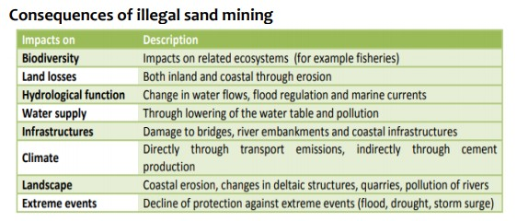Sand on the riverbed acts as link between river water & ground water; SM might lead to contamination of GW due to downstream erosion. Eg SM in Papagani area of Karnataka- massive depletion of GW
* SM will impact blue economy by destroying corals, microbes, fisheries, and crutacean
* Forcing the river to change its course as sand prevents river frequent course change
* Threat to agri due to dec water tables
* Coastal erosion- eg Kihim Beach alibaug- people forced build walls to protect from sea
* Economic - Revenue loss to exchequer
* Infra-low quality sand- weak buildings

##### Measures taken:

##### Enforcement & Monitoring Guidelines for Sand Mining (EMGSM-2020)

* + - All district to prepare a comprehensive mining plan for the district based on DSR and define the mining and no mining zones considering environmental and social factors
      * 2016 guidelines reqd. state require the preparation of District Survey Reports (DSR) before grant of mining lease but they were often not comprehensive enough, allowing space for illegal mining. Thus 2020 guidelines give detailed procedure of how the DSRs are to be made
    - Abandoned stream channels on the floodplains should be preferred rather than active channels
    - Use of technology such as drones, mobile application, night vision equip,etc for checking illegal mining, estimation and monitoring of reserves
    - Annual audit of each mining lease shall be carried out
    - Mining depth should be restricted to 3 meters

##### Sustainable Sand Mining Management Guidelines, 2016

* + - Calls for promotion of manufactured sand, artificial sand, fly ash and other alternative technologies
    - Calls for training of architects and engineers
    - Positive incentives to initiate a shift for lowering dependency on sand
  + MH: Policy requires permission from Gram Sabha along with environmental clearances
  + UP: Establishment of ‘Special Mining Squad’ to tackle sand mafia
  + 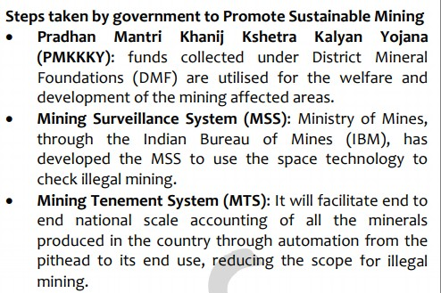

##### Examples:

* + Various area of Tuticorin in TN are facing agitation of fishermen due to illegal mining
  + Satellites images have clearly shown the how the coast line is receding back in Kerela
  + Sand on the riverbed acts as link between river water & ground water; SM might lead to contamination of GW due to downstream erosion. Eg SM in Papagani area of Karnataka- massive depletion of GW

##### 2013: Illegal mining: Consequences, current measures and trend wrt. pre and post 2014

##### Consequences

* Economic
  + Revenue loss , affect legitimate dev of mining sector
* Health- workers safety eg Ksan coal mine Meghalaya rat hole mining deaths
  + Unsustainable mining operations- rat holes
  + HR violations
* Poltical- involvement of other TOC’s like human trafficking - results in crim of politics , corruption
* Enviroment- Above sand mining points(box) eg protests for mining op in wildlife parks
  + Affect GW- drinking water
* Social- Impact on tribal alienation
* Current Measures
  + Minining Survelliance System - Covered above in sand mining
  + **National Mineral Policy (NMP) 2019** (Target: For non-fuel and non-coal minerals)- for encouraging legal mining
    - Encouraging the private sector to take up exploration, on a

##### revenue sharing model

* + - Allow **transfer** of mining leases from one company to another and support in their **merger and acquisition**
    - Introduces the concept of i**ntergenerational equity** (for welfare of generations to come)
    - **Harmonise** taxes, levies, and royalty with the world benchmarks
    - Provisions for e-governance, IT-enabled systems, awareness and information campaigns
  + Khan Prahari App: Coal Ministry’s app for reporting illegal coal mining
  + Star Rating Of Mines, 2016 given by Indian Bureau of Mines based on whether the mining company is working without adversely affecting the social, economic and environmental well-being of present and future generation
* **UN Secy-Gen Guterres** flays India’s coal subsidy and opening up of coal auctions in the era of clean energy at an event hosted by TERI. His arguments were:
  + India's subsidies for fossil fuels are around **seven times** bigger than subsidies for clean energy
  + Investments in renewable energy generate **three times more jobs** than investments in polluting fossil fuels
  + However, for India **coal is a necessary evil** because 1) Wind and solar power are nondispatchable, meaning electricity can be generated only when there is fast wind blowing or there is appropriate sunshine 2) Land requirement for solar based powerplant is 10 times that of thermal power plant 3) Bottlenecks in acquiring nuclear fuel and nuclear Technology 4) unemployment if we shut down coal

**Way forwards**- address consequences with general way forward points

**Solid Wastes**

##### 2018: Solid wastes: impediments in disposing, how to remove safely, legal measures, other types of hazardous wastes and their management

**Intro -** More than tenth of the world's **waste** is generated in **India**

India produces 277 million tonnes of municipal solid waste every year, according to a 2016 estimate and only 22-28 % of this waste is processed and treated

**Gandhiji** - Cleanliness is next to Godliness

* Impediments in disposing:
  + Lack of awareness among people- neglect of 3R’s
  + Municipal authorities responsible- but insufficient budgets for waste collection,disposal - Also there is lack of accountability
  + Lack of strategic MSW plans, regulatory framework
  + Lack of innovation,start ups in waste mgmt
* Impact on environment
  + Landfills have reached way beyond their capacity; Emissions of methane

→ absorbs the sun’s heat → global warming

* + Contaminates soil and groundwater due oozing out of harmful chemicals such as Leachate
  + Untreated disposal into rivers is affecting marine lives → threat for blue economy and biodiversity
  + Solid waste have chemicals which can enter the food chain of humans as well as animals
* Measures to remove it safely:
  + Biomining and Bioremediation, Decentralization of waste management eg: Ambikapur
  + Local Initiatives: Garbage Café at Ambikapur offers meals to ragpickers and the homeless, in exchange for plastic waste
  + Waste treatment techniques- Sanitary landfills,Pyrolisis,Incineration plants

##### Measures Taken:

* + Solid Waste Management Rules 2016
    - Segregation at source: mandated the source segregation of waste into three streams - Biodegradables, Dry and Domestic Hazardous waste and scientific disposal
    - Given power to the local bodies across India to decide the user fees, spot fines, etc
    - Emphasize promotion of waste to energy plants
    - Constituted a Central Monitoring Committee under the chairmanship of Secretary, MoEF&CC to monitor the overall implementation
  + Star Rating Protocol 2018 to institutionalize a mechanism for cities to achieve *Garbage Free status*, and to motivate cities to achieve higher degrees of cleanliness. Ambikapur, Rajkot, Surat, Mysuru, Indore and Navi Mumbai have been rated 5-star
  + SBM (G) Phase-II will focus on Open Defecation Free Plus (ODF Plus), which includes ODF sustainability and Solid and Liquid Waste Management (SLWM)
  + Swatch survekshan survey by MoHUA
* Best practices- door to door collection with song to promote sense of unity

##### Way forward:

* Need for integration of waste pickers,kabadiwala into formal system ,SHG
* Municipal bonds,user fees from citizens for financing MSW operations
* Set up solid waste processing facilities by all local bodies in india
* Training, Tech
* Marketing of city compost - use on farm lands
* Waste to energy plants- DISCOM should purchase that power
* Culturing the waste with bacterial species for producing methane, commonly known as biogas
* Fuel obtained from plastic waste has high octane rating. It contains no lead and is known as “green fuel”

**E Waste**

* Term used to describe old, end-of-life or discarded electronic appliances
* India is the third largest electronic waste generator in the world after China and the USA as per the Global E-waste Monitor 2020
* Expected to increase further due to growing IoT devices
* Issues:
  + Release of Hazardous chemicals such as lithium, cadmium, arsenic, etc.
  + Leading to global warming by ineffective release of gases during incorrect disposal such as CO2 (already reached >400 ppm)
  + Low recycling capacity: Only 17% of the e waste is recycled globally
* Steps taken in India
  + E-waste management act 2011 brought extended producer responsibility
  + E Wate (Mgmt) Rules 2016 brought manufacturers, dealers, refurbisher under its ambit
  + Rules amended in 2018 to channelise e-waste generated in the country towards authorized dismantlers and recyclers in order to further formalize the e-waste recycling sector
  + India’s first E-waste clinic is going to be set up in Bhopal
* Way Forward:
  + Need for adequate data on e-waste to understand its quantum and design approapriate policies
  + Create awareness and educate people on how to dispose the same through IEC campaigns
  + Formalise collection & recycling of e waste
  + Need to extend the life cycle of products by promoting the concept of *circular economy* (which will be departure from the traditional consume and throw away model)

**Biomedical Waste**

* Bio-medical Waste Management Rules 2016 (amended in 2018)
  + Pre-treatment of waste through disinfection in the manner prescribed by WHO
  + Bio-medical waste has been classified into 4 categories
  + Regular Training and Immunisation of all health care
  + Establish GPS and Bar-coding facility at Common biomedical waste treatment facility
* Issues:
  + Write general impediments from SWM answer
  + Poses health risks for garbage collectors and disposal team
* Way Forward:
  + Penalise and take strict actions for defaults
  + Involving private sector to address issues of lack of resources
  + Other General points
* Good steps: Government has reported that the recycling rate of 10% in 2017-18 has risen to 20% in 2018-19

**Plastic Waste**

Municipal bonds,user fees from citizens for financing MSW operations26000 tonne per day-CPCB, Single use P most harmful, only one third collected and processed

PW is fueled by consumerism

##### Impact

* Soil polln- toxic chemical leaching- harm agri- birth defects
* Poisoning oceans- affect corals- takes 1000’s years to disintegrate
* Air polln- by plastic burning
* Health- Plastic bags breeding ground for mosquitos
* Bioaccumulation- enter food chanin- impact bio-D
* Natural disaster- block drainage-urban floods

##### Gov efforts

* PW Mgmt rules 2016- min thickness of plastic bag,inc cost, resp of local bodies,EPR,street vendor -not allowed, action plan by states, resp of bulk generators like event co., brand co,
* Promote P in road construction
* Phasing out MLP which is non recyclable, explicit pricing - PW mgmt ammendment rules 2018
* Eliminate SLP by 2022 pledge at UNEP conf

##### Challanges:

* States failing to submit action plan despite NGT order
* Lax monitoring, poor EPR, SPCB not effective
* Large scale informal sector

##### WF

* Bioplastics, tech ,awarness,innovation etc

Plastic in oceans- Great Pacific garbage patch- 1.8 trillion peice of plastics

##### Steps taken:

Impact on - fishes,shipping,climate cycle,disasters etc

* UNEP #Clean seas campaign
* Basel conv on transb waste mov- included plastic
* G20 action plann on marine plastic litter

**River Conservation**

##### 2015, 1985: River Ganga: Status, gaps, programmes, incremental success comp to past programs, general framework for river water pollution control and management

##### General framework for river conservation

* CPCB- 350 polluted rivers with 45 critically polluted
  + have toxic metals beyond permisible limits
  + increase in bio-chemical oxygen demand
* Sources of R polln- Point(industry pipes etc),Non point(agri,human)
* Reasons for pollution
  + Rapid urbanisation (pressure on resources) and encroachment of wetlands (act as natural filters)
  + Improper treatment of waste disposal due to lack of resources such as funds/manpower
  + Low priority is accorded to the enforcement of laws by SPCBs
* Gov steps for R conservation:
  + National R conservation plan- dec polln
  + National water monitoring prog by CPCB
  + Namami Gange
* Way F
  + Recycle and reuse of waste water(israel)
  + Discharge only acc carrying capacity/self cleaning of rivers
  + SW mgmt,awareness
  + Maintain ecological flow
  + Other ganga conervation points

Ganga river pollution: Largest,holiest,sacred river

Causes of polln- population density,rituals and religious material,holy bathing,industrial sewage polln,OD etc

Govt efforts:

##### Namami Gange

* + It is an Integrated Conservation Mission for river Ganga, approved as ‘Flagship Programme’ by the Union Government in 2014 with budget outlay of Rs.20,000 Crore.
  + Sewerage infra,river surface cleaning,monitoring industrial eﬄeunts,ganga gram-prevent ODF, river front dev
  + 5 tier structure under EPA 1986:- National ganga council (Heade by PM; NGC replaced the NGRBA),Empowered Task Force (Union Min), NMCG (exec; implementation arm of NGC), State ganga committee, District Ganga comitee
* Status
  + +ves: 4000+ villages ODF, DO improved at many places,zero black liquid discharge achieved, inc in nearby afforestation
    - 60+ sewage management projects under implementation in the States
  + +ves:Far away from being clean, bathing standard only 4 out of 41 location
    - Just 29% of the sanctioned budget are spent
* Main Pillars of the mission:
  + River Surface cleaning
  + Afforestation
  + Industrial Eﬄuent Monitoring
  + River front development
  + Conservation of Aquatic life and biodiversity
* Challenges
  + Decreased ecological flow despite provisions for “Aviral Dhara”
  + Inadequate Sewage treatment-Ganga basin approximately 12,000 million litres per day (mld) sewage is generated but treatment only 4,000 ml
  + Lack of coordination as Jal Shakti Ministry signed MoUs with 10 other ministries; But no detail is avaliable
* Way Forward
  + Need for increase and more effective sewage treatment
  + Sludge control in ODF villages
  + CAG- not full funds utilised
  + Ecological flow ensure- by ensuring that hydropower project dont make ganga “hydrological deserts”
  + Governance coordination
  + Promote decentralised sewage treatment plants (dSTP) at the colony level. Reuse treated wastewater for irrigation and empty into natural drains
  + Organic agriculture: The cumulative use of pesticides has doubled in the last one decade and most of it runs off in our river
* Other Programs related to Ganga:
  + Ganga Action Plan
  + Clean Ganga Fund
  + Bhuvan-Ganga Web App: Involvement of the public in monitoring of pollution entering into the river Ganga.
  + Ban on Waste Disposal: In 2017, the National Green Tribunal banned the disposal of any waste in the Ganga.

**River Inter-Linking**

##### 2017: River linking: +ves, challenges, Inter vs Intra, impacts on environment, examples

* The National River Linking Project envisages the transfer of water from water ‘surplus’ basins where there is flooding, to water ‘deficit’ basins. It includes two components:
  + Himalayan Rivers Development Component: includes storage reservoirs on the Ganga and Brahmaputra rivers
  + Southern Water Grid: includes 16 links that propose to connect the rivers of South India
* As of now, six ILR projects — the Ken-Betwa, Damanganga- Pinjal,

Par-Tapi-Narmada, Manas-Sankosh-Teesta-Ganga, Mahanadi-Godavari and Godavari-Cauvery (Grand Anicut) — have been under examination of the authorities.

* Positives:
  + Adress water stress- Niti Aayog -I facing worst water crisis-
  + Shift water usage from ground water to surface water
  + Hydropower generation;
  + Irrigation benefits- benefit drought prone regions- judicious use of water resources of country- help in 2nd GR (can also be linked to inc pop and food security)
  + Disaster mgmt- help in swift diversion of water during floods
  + Round the year navigation, lower carbon footprint, logistics and movement of freight,
  + Prevent fresh water discharge into sea
* Issues of implementation- Federal disputes- surplus state hesitant to transfer water
* Issues:
  + Expensive and energy intensive proposal to link northern and southern region (due to plateau)
  + Destruction of forests, wetlands and local water bodies shows there is no holistic assessment
  + New analysis of rainfall data reveals that monsoon shortages are growing in river basins with surplus water
  + Displacement of people which would bring rehab issues eg in Ken betwa- led to submergemce of forest and destruction of habitats (impacted Panna Tiger Reserve)
  + Altering the natural course of river may make areas surrounding it prone to hazards; Even flooding of river is needed and is a natural phenomenon thus negating the concept of deficit and surplus
  + International logjam in discussion with neighbours (such as Bhutan/BG)
  + Loss of biodiversity (eg: riverine species) and forests downstream of a donor river will occur. It can harm many ecological factors like delta formation, growth of mangroves
  + Sediment management of Himalayan rivers is a big challenge
  + Decline in freshwater entering the sea may impact climatic phenomenons along with marine life
* Way Fwd:
  + The necessity and feasibility of river-interlinking should be seen on case to case basis, with adequate emphasis on easing out federal issues
  + Exhaust options such as watershed development, rainwater harvesting, ground water recharge, optimising existing infrastructure and cropping methods which have not been explored fully

##### 1993: Merits and demerits of river valley projects (also asked in GS-1, 2020)

-ve impacts of dams:

[https://www.drishtiias.com/daily-updates/daily-news-analysis/environmental-impact-o](https://www.drishtiias.com/daily-updates/daily-news-analysis/environmental-impact-of-dams) [f-dams](https://www.drishtiias.com/daily-updates/daily-news-analysis/environmental-impact-of-dams)

The damming of rivers for hydro-electricity production or irrigation is reducing the amount of sediment flowing downstream

Alternative to dams:

Reworking on capacity of existing dams (rather than constructing newer dams)

It is time we follow countries like Japan that have created multiple sub-surface dams. Unlike a surface dam, water loss by evaporation is minimal in underground dams.

Additionally, no siltation takes place in the reservoir and the potential disaster like collapse of dams can be avoided.

building coastal reservoirs

### Water Conservation (WC)

##### Facts:

* NITI Aayog - 60 crore Indians face high water stress, 75% households do not have drinking water on their premises, also 70% of drinking water contaminated acc to acceptable standards
  + 21 cities inc Delhi,chennai running out of GW , delhi- water contamination acc to CPCB standards
  + Demand for potable water may outstrip supply by the year 2030 if precautionary steps are not taken
* India is a net ‘virtual water exporter’ (mainly due to rice exports, buffalo meat)
* The Composite Water Management Index (CWMI) report also states that by 2030, the country's water demand is projected to be twice the available supply, implying severe water scarcity for hundreds of millions of people and an eventual six per cent loss in the country's GDP
  + 21 major cities (including Delhi, Bengaluru, Chennai, Hyderabad) were on the brink of exhausting groundwater resources (as per CWMI)
* The average annual per capita water availability in the years 2001 and 2011 was assessed as 1816 cubic meters and 1545 cubic meters respectively which may further reduce to 1486 cubic meters in the year 2021 (PIB Data)
* India is not a water short country as it has an average annual rainfall of 119 cm while world average is 99cm. however, the spatial and seasonal distribution of rainfall, along with inefficient use of available water makes water a precious

resource with a growing need to conserve it (intro for PYQP 2015)

* India is home to more than 17 per cent of the world's population, which depends on 4 per cent of the planet’s freshwater resources. By 2030 water demand in the country is estimated to be twice the available water supply.

**Issues**: (categorise on domestic, industrial, agri, pollution (river, GW) etc)

* Overexpolitation - low awareness for W.C coupled with increasing purchasing power of people
* Hesitant gov policy- water freebies to farmers, cheap water to cities- overuse
* Increased pollution of rivers- high cost of purification, industrial wastes, domestic wastes, GW pollution-arsenic,fluoride etc, microplastics found in Ganga (study of Ganga by NGO names Toxics Link)
  + High level of fecal coliform (microbe from human excreta) found in Yamuna
* Antiquated legal framework to regulate groundwater- Since groundwater is considered a part of land and gives landowners unrestricted entitlement to it, the government is left with little leeway to act
* Statistics from the Central Water Commission reveal that India receives as much as 4,000 billion cubic metres of rainfall, but only a mere 18% of that is captured efficiently (rest is lost to evaporation and other factors)
* Unscientific agri- 90% consumption in agri,water intesive crops like rice due to MSP, flooding the fields **(Problem in PJ)**
* Encroachment of foodplains, pavements over lakes → to reduction in process of recharging (Water Shortage in **Chennai**)
* Lack of water resuse- no waste water treament on large scale
* Close linkages b/w health, sanitation and water - (eg: of water borne diarrhoea, pneumonia)
* The most common reason is that water is not valued in India
* Uneven spatial & temporal (only 4 months) distribution of rainfall - comparison of western ghats and NE region with northern parts of Kashmir and Western Rajasthan
* Entrenched mindsets and practices leading to gendered access to sanitation facilities continue to create hurdles
* Economic factors:
  + Poor water use efficiency- India uses almost twice the amount of water to grow crops as compared to China
  + Poor industrial standards- Proliferation of industries, such as soft drinks
* Geographic factors:
  + Overburdened river systems- Majority of the population is dependent on a few major river systems, especially the Ganges and its tributaries
  + Unequal distribution- Some regions in India being water surplus such as Himachal Pradesh, while others being water scarce such as Rajasthan
* Anthro factors
  + Policy issues- India lacks a comprehensive water policy with proper guidelines
  + Water diversions- Construction of dams & hydroelectric projects, and water diversion for irrigation
* Other reasons: overpopulation (17% popu and 4% fresh water), Lack of recycling capacity for used water, Climate change increases incidences of droughts and reduce annual precipitation, Surface water run-off (leading to no recharge of ground water; we can also link concretisation of cities), Lack of metering and poor enforcement of water pricing mechanisms, Water borne diseases due to unsystematic disposal of waste

##### Impact:

* Lowered agricultural productivity: In 2019, about 50 % of India grappled with drought like conditions.
* Water crisis: According to CWMI 2018 of NITI Aayog, 21 major cities
* Desertification: Nearly 30% of India’s land area has been degraded through deforestation, over-cultivation, soil erosion and depletion of wetlands.
* Inter-state conflicts: India has witnessed inter-state conflicts, such as Karnataka–Tamil Nadu or Haryana–Punjab due to dwindling water resources
* Diseases: Scarcity of water forces households to use non-potable water. It has severe health implications. According to the World Bank, 21 percent of communicable diseases in the country are related to unsafe water

##### Govt efforts:

* Jal Shakti Abhiyaan- jan aandolan like SBM, focus on water stressed districts- campaign for efficient use, MGNREGA for construction of farm ponds,water harvesting etc
  + Special pani panchayats- identify prob and soln, use of IT/space,afforstation,watershed dev,renovation of traditional water bodies
  + Catch the Rain Initiative (makes sense as we only capture 18%)
* Jal Jeevan mission(modified NRDWP)- every rural household tap water by 2024
* CGWB- GW extraction guidelines- user fees etc
* Niti Composite water mgmt index 2.0 - evaluate and rank states on WC
* National Water Informatics centre- for water data analytics
* Atal Bhujal Yojana

##### Best practices:

* Paani Bacho, Paise Kamao (save water, earn money) scheme: It was launched by Punjab State Power Corporation Limited (PSPCL) to provide direct benefit transfer for electricity to agricultural consumers
* Watershed Development in Ralegan Siddhi
* Mazhapolima model which is a decentralised well discharge program using rainwater harvesting (Thrissur Distt. Kerela)
* Giving further impetus to traditional water harvesting strutures such as Zing of Ladakh, Bundela Tanks, Kere of Deccan plateau, etc
* **Jain Irrigation** (NSE listed Co.) has set up drip irrigation pilots for paddy in

Haryana and Tamil Nadu. The results of these pilots indicate while it takes 3,065 litres of water to produce 1 kg of paddy grain under traditional flood irrigation, under drip, it can be reduced to just 842 litres (70% saving in water 😵)

* Chouka System (refer image)
* 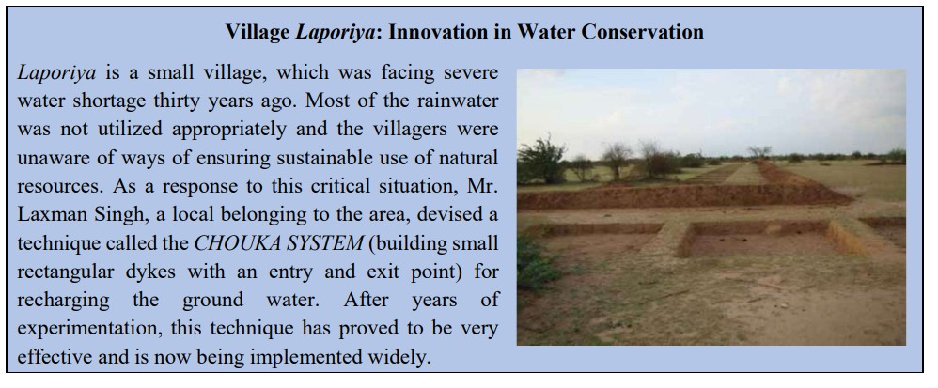

**Way forward**: (categorise on domestic,industrial, agri, pollution and conservation (river,GW) etc)

* More Grassroot W.C efforts- eg Dong bandh system of Assam- irrigation system helping fight drought
* Better MSP to crops requiring less water- nudge farmers from water intensive crops
* Rewards,appreciation to farmers,best practices of citizens,NGO’s
* **Need for Synergy:** Between Jal Shakti Ministry and other such as Urban, Local Self-Government, Environment
* Commercial charges for water beyond a limit to big farmers, GW by households,industries
* Reuse- eg Israel converts 90% sewage water into use for agri
* Educate in school- 3 R’s Reduce ,recycle,reuse
* Focusing on efficiency of irrigation as well as hydel projects
* PPP for effective water governace in cities- help in treatment,supply,data analytics on use
* Inter
* Sustainable agriculture practices- Using practices such as Zero Budget Natural Farming(ZBNF) along with moving from water intensive to more sustainable crops, crop diversification
* Improve water use efficiency – Utilize efficient usage techniques such as water rationing, auto cut offs in cities as well as villages. Ex: City wide water purification systems instead of home RO’s (eg: Puri, Odisha)
* Compulsory annual water audits for industrial users apart from mandating impact assessment for granting no-objection certificates (NOCs) for groundwater extraction.
* National Water Policy emphasises on ‘river sensitive’ development plans; Removing concrete structure s and employing ‘green infrastructure’ - For river

basin mgmt, AI can be used for biodiversity mapping, Drones can be used to floodplain mapping and Big data be used for river health monitoring

* **Water accounting and auditing** to address water shortages and scarcirty
* Payment for Ecosystem Service (PES) Model of Himachal Pradesh can be adopted (villages of downstream make payment to upstream villages to ensure ecology impact); On these lines, we need to better recognize contribution of Himalayan states for keeping critical ecosystems intact (10 himalayan states demanded green bonus in 2019)

**National Water Policy 2012 2013: National Water Policy 2012**

The NWP currently in force was drafted in 2012 and is the third such policy since 1987. Key features of NWP 2012 are:

* Integrated Water Resources Management approach: Concept of an Integrated Water Resources Management approach that took the “river basin/ sub-basin” as a unit for planning, development and management of water resources
* Minimum levels: Maintain ecological flow among rivers eg: “Aviral Dhara” provision in Namami Gange
* Potable water: Minimum quantity of potable water is to be made available within easy reach of households
* Inter-basin transfers: Transfers should be considered on the basis of merits of each case after evaluating the environmental, economic and social impacts of such transfers

The committee to draft the NWP has been formed chaired by Mihir Shah. National Bureau of Water Use Efficiency is proposed to be set up in order to enhance water usage efficiency, especially in domestic and industrial sectors.

The quantum of water is not less in this country but management of water is required. So next agenda should be managing water properly.

##### 2020: What are the salient features of the Jal Shakti Abhiyan. launched by the Government of India for water conservation and water security?

* Aimed to make water conservation a ‘people’s movement’ through ongoing schemes like the MGNREGA and other government programmes
* 2 phase campaign by Jal Shakti Ministry to conserve water.
* Phase1: from 1st July, 2019 to 15th September, 2019.
* Phase2: from 1st October, 2019 to 30th November, 2019 for States receiving the North East retreating monsoons.
* They’ll focus on following areas to conserve water:
  + Rainwater harvesting, Renovation of traditional water bodies/tanks, bore well recharge structures, watershed development
  + Water reuse, intensive afforestation
* Strengthen the ongoing **Jal Jeevan Mission** which aims to to provide Functional Household Tap Connection to every rural household by 2024
* JSA is partly modeled and driven by some success stories such as Anna Hazare-led efforts in Ralegan Siddhi
* Key Issues:
  + JSA was planned based on the boundary of the districts rather than taking integrated basin approach
  + lack of proper engineering supervision of these structures
  + No parameter to measure the outcome of this mission-mode campaign
  + No additional funding

💡 Nov 2021: Analyse Qs related to Drainage linked to water conservation (only 2-3 qs overlap with environment)[Indian Drainage Systems: GS-1 Geography](https://quip.com/PO0LAGmApyDU#UMGACAEpbpu)

**Ground Water Extraction**

* India uses the most groundwater in the world approximately 25% of the global groundwater extraction.
* According to an estimate, groundwater accounts for nearly 80 per cent of the rural domestic water needs, and 50 per cent of the urban water needs in India
* New Guidelines for GW extraction:
  + Mandatory No objection certificate (NoC) for GW extraction - Valid for 2-5 years
  + NoCs in ‘over-exploited’ areas will only be granted to MSME (and not big industries)
  + Environmental Penalty for commerical extraction without valid NoC
  + Exempt from NoC: Indv dometic consumer in rural/urban; Agri activities, etc
* Criticism: 90% of GW is for irrigation and the same is exempt

**Atal Bhujal Yojana**

* Aim: To improve ground water management in priority areas in the country through community
* Central Sector Scheme to be implemented over a period of five years from 2020-21 to 2024-25, with World Bank assistance.
* Priority areas: Fall in the states of Gujarat, Haryana, Karnataka, Madhya Pradesh, Maharashtra, Rajasthan and Uttar Pradesh
  + These States represent about 25% of the total number of over- exploited, critical and semi-critical blocks in terms of ground water in India
* The scheme will also facilitate convergence of ongoing Government schemes in the states by incentivizing their focussed implementation in identified priority areas
* Funds under the scheme will be made available to the participating states as

##### Grants.

* Funds under the scheme will be provided to the states for:
  + Strengthening the institutions responsible for ground water governance
  + Encouraging community involvement & foster behavioural changes Other initiatives by Govt:
* National Aquifer Mapping and Management Programme: It was initiated as a part of the Ground Water Management and Regulation scheme to delineate and characterize the aquifers to develop plans for ground water management.

**Ground Water Pollution**

* As per the recently released report by CGWB, 21 states across the country have pockets with arsenic levels higher than the Bureau of Indian Standards’ (BIS) stipulated permissible limit of 0.01 miligram per litre (mg/l)
* Reasons- Inland salinity and polln in lakes, coastal salinity-sand mining,unscientific extraction
* Impact- on human health -diseases (blue baby,fluorosis), biomagnification due to agri uptake
* Government Efforts to control the Ground Water Pollution
  + A Master Plan for Artificial Recharge of Groundwater” has been developed by the CGWB in 2013. According to this plan, over 85 billion cubic metres will be recharged in rural and urban areas in a phased manner by 2023.
  + Atal bhujal Yojna National Project on Aquifer Management (2016)
* Way Forward: The CAG has made the following recommendations with regard to the prevention and control of pollution of groundwater:
  + The Ministry of Environment, Forest and Climate change needs to establish enforceable water quality standards for lakes, rivers and groundwater to help protect ecosystem and human health.
  + Penalties need to be levied for violations of water quality standards.
  + States need to take measures for source control of pollutants through sewage and agriculture runoff entering water bodies in projects for conservation and restoration of lakes.

##### Types of Pollution, impacts, measures (one point each)

* Air,water,soil,noise,radioactive,e-waste,thermal,plastic

### screenshot_20210330-214004.jpgAir Pollution

* Facts-
  + WHO- 14/15 most polluted cities of world in india
  + India 168/180 in Env perforamce index ranking- low ranking due to air polln deaths
  + Green Peace Report - AP killed 54k people in delhi alone in 2020
* Need- The **Right to Clean Air** stood recognized as part of Right to Life and failure to address air pollution is a denial of Right to Life under **Article 21**
* Causes of Air pollution in India
  + Emissions from burning of fossil fuels which include vehicular emissons, industrial emissions.
  + Emissions from stubble burning- in agriculture
  + Release of dust and chemicals- from mining operations.
  + Other Causes- Dust Storm, Forest Fires, Deforestation, Landfills, Electronic Waste etc.
* Impacts of Air Pollution
  + On Health- A recent study by the Centre for Science and Environment (CSE) revealed that life expectancy in India has gone down by 2.6 years due to deadly diseases caused by air pollution.
  + On Economy- Estimates peg the economic cost of air pollution to the Indian economy at more than US$150 billion a year due to

pollution-related death, sickness and welfare

* + Climate Change- which include global warming, acid rain, depletion of ozone layer etc.
  + Impact on Wildlife: Toxic chemicals present in the air can force wildlife species to move to new place
* Some Steps taken by the Government
  + Clean Air- India Initiative: to curb air pollution in Indian cities by promoting partnerships between Indian start-ups and Dutch companies and build a network of entrepreneurs working on business solutions for cleaner air.
  + Under it, an ‘INDUS impact’- using paddy straw as feedstock to make materials that would find use in construction and packaging.
  + Notification of National Ambient Air Quality Standards and sector-specific emission and eﬄuent standards for industries.
  + Launching of National Air Quality Index (AQI).
  + Promotion of fuel standards- Leapfrogging from BS-IV to BS-VI fuel and ban on pet coke and furnace oil.
  + Subsidy to cooking fuel under Pradhan Mantri Ujjwala Yojana (PMUY) to curb indoor pollution.
  + Encouraging Alternatives: Promotion of public transport and network of metro, e-rickshaws, promotion of car-pooling etc.
* Solutions:
  + Fly Ash Management: Fly ash is a by-product of burning coal in thermal plants. It contributed to land, water and air pollution unless managed properly. Fly ash can be used in agriculture (to boost water holding), in construction (stronger concrete mix), etc.
    - Govt efforts: ASH TRACK app for fly ash users and power plants; Mandatory use of Fly ash in all govt. schemes (at present 63% of fly ash is being utilized)
  + Decarbonising Transport: Project by NITI Aayog and ITF and aims to provide measures such as Pull policies (to attrach citizens) and Push policies (eg: lesser parking, high tax on fuels)
  + FAME II - Incentives for adoption of EVs and hybrid vehciles(coming of TESLA in 2021-shows sincerity of govt)
  + Tackling emission from agriculture such as methane from rice cultivation and livestock; NO2 released from crop residue burning
  + Cleaner coal technologies such as wet scrubbers, coal washing, Carbon Capture, Utilization & Storage (CCUS)
* Way Fwd
  + Need for future R&D in newer technologies to contain air pollution such EV infra
  + Adoption of climate friendly agri practices such as zero tillage, bio fertilizers, etc.
  + Skill development & training initiatives in upcoming technologies

**National Clean Air Programme (NCAP)**

##### 2020: What are the key features of the National Clean Air Programme (NCAP) initiated by the Government of India?

Start with data on air polln overview

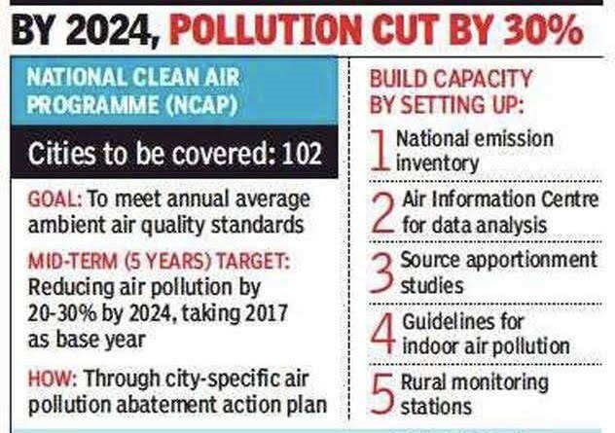Aim: polln control to cut PM10,2.5 by 20-30% by 2024- implement in 102 non-attainment cities

##### Features of NCAP(Central sector)

* Mitigation
  + monitoring,plantation drive,tech support,regional and transboundary plan(Male Declaration on air polln)
* Knowledge and Database
  + Studies on NA cities,NE inventory
* Institutional strenghtening
  + National and state apex comitee, Air info centre, training awarenss etc

##### Significance

* Maiden attempt to frame national framework
* Muti-sec collab, urban+rural

##### Challange

* Not legally binding on state, fiscal issues

### Land Degradation

##### 2012: Desertification: Cause, extent, remedial measures, economic activities prevalent in arid regions

* According to Desertification and Land Degradation Atlas; published by ISRO - about 30 per cent of the country’s total area, is undergoing degradation
* Meaning: Desertification is a slow process in which land productivity and resilience steadily decline.
  + Acc to UNCCD , desertification refers to land degradation in the drylands (arid,semi arid,dry sub humid areas) and not connote expansion of deserts.
  + Soil erosion, desertification and salinisation are various components of land degradation
* Causes:
  + Loss of soil cover due to due to rainfall and surface runoff = one of biggest reason
  + Agriculture & allied: unsustainable agricultural practices (eg:, overgrazing (eg: led to destruction of grassalands in GJ), salinization by over irrigation, Slash and burn agriculture (eg: NE region and Central india)
  + Climate Change: causing variation in rainfall and seasonal patterns
  + Deforestation eg: as done by timber mafia in MH
  + Rampant mining and expanding urbanisation eg: impact on the state of Goa
* Benefits:
  + Ecological benefits: Carbon sinks (restoration of depleted wetlands, forests), Enhance the biological productivity of soils; Preservation of biodiversity (gharials), Ecosystem services ( nutrient recycling, water percolation)
  + Socio-Economic benefits: Sustainable agriculture (organic farming,), Stop distress migration , Livelihood generation
* Remedial measures:
  + Take steps opposite to causes written above
  + Sustainable agricultural practices such as mixed cropping, mulching, soyabean plantation to restore nutrients
  + Shelter belts at desert margins
  + Terrace farming and contour bunding in hilly regions
* Govt efforts:
  + Land Deg Atlas by ISRO
  + Bonn challenge pledge - recovery of 26 mn hectares now by 2030 by india - increase of 5mn at UNCCD COP 14 shows govt commitment (global pledge of 350mn by 2030)
  + Govt schemes -perdrop more crop,national afforestation policy-agro,social,farm forestry
  + UNCCD COP 14 in delhi- first time in india- Delhi declaration
  + ISFR 209- aim of 33% forest cover- promote afforestation
  + Green Wall: 1400 km length & 5 km width of trees; From Porbander to Panipat; Aim to control desertification, dust storms, pollution, etc
* International efforts
  + UN decade on ecosystem restoration(21-30)
  + LD neutarlity by 2030 by UNCCD
  + New york dec on forests- to hald deforestation globally
* Case Study:
  + “Familial Forestry” Campaign in RJ (concept of Mr. Shyam Sunder Jayani)- Joined by 10 lakh families (FF means making tree a green family member)
    - UNCCD praised Familial Forestry of Rajasthan as "a unique concept of Shyam Sunder Jyanithat relates a tree with a family, making it a green family member
  + Miyawaki Method - dense native forests can be grown faster
* Way forward- reducing food waste, farming with ecosystem obligation, control jhum cultivation, global funding for developing countries, sustaianble land management through encoraging local participation
  + Water management practises, community participation, and sustainable and climate smart agricultural practices are the major ways to prevent desertification
  + Environment Minister Harsh Vardhan lauded a lowland ecosystem management system in Burkina Faso, and support for combating land degradation in dryland ecosystems in China

State wise examples:

[https://www.downtoearth.org.in/news/environment/desertification-setting-in-across-a](https://www.downtoearth.org.in/news/environment/desertification-setting-in-across-a-quarter-of-india-66407)

[-quarter-of-india-66407](https://www.downtoearth.org.in/news/environment/desertification-setting-in-across-a-quarter-of-india-66407)

### Environmental Degradation

##### 2004: Economic growth vs Env. degradation

Kinda related to ecological balance

If you think money is more imp than env, try holding your breath while counting your money

*Making Peace with Nature Report* by UN highlighted that our social, economic and env challenges are interlinked; eg: We cannot achieve SDGs when climate change is undermining our food & water supplies across the world

##### 2019, 1987: Ecological Balance: Steps to manage, Concept of carrying capacity and role of CC in sustainable development of a region

* Carrying Capacity be defined as the population that can be supported indefinitely by its supporting systems.
* CC depends on- amount of resources available, population size,amount of resources each is consuming
* 17% of population thrives on 2.4% of the Indian mainland (denotes excess pressure)
* Role of CC in planning for S.D of region
  + Determining population of a given area that can be sustainability supported by env- eg in case of housing schemes(not too many houses in less area)
  + Need for population control in family plannings
  + The concept of carrying capacity of an ecosystem can be very useful in proper agricultural planning eg: Not growing paddy in PJ and avoiding sugarcane in Vidharba
  + GW extraction more than carrying capacity might lead to conditions of droughts
  + Air - not too many vehicles in city- promote car polling,high parking tax
  + Water- Not overextraction- lead to pollution
  + Land- Sust land use , prevent shifting cultivation
  + Focus on optimum utilisation of resources- Awareness on 3R’s and circular economy (niti aayog)
  + Need for min inequality for balanced resources use
* Gandhi quote- for everyone need but not for everyone greed

### Wetlands

* **Meaning**: Wetlands occur where water meets land. They’re lands transitional (ecotone) between terrestrial and aquatic ecosystems
* India has nearly **4.6%** of its land as wetlands, and has **42** wetlands designated under Ramsar convention
* The **Ramsar Convention** uses a broad definition of wetlands. It includes **all lakes and rivers**, underground aquifers, swamps and marshes, wet grasslands, peatland, oases, estuaries, deltas and tidal flats, mangroves and other coastal areas, coral reefs, and **all human-made sites** such as fish ponds, rice paddies, reservoirs and salt pans
  + Peatlands are wetlands whose soils consist almost entirely of organic matter derived from the remains of dead and decaying plant material. They are found all over the world
  + Mangroves are ecosystems which grows in the coastal intertidal zone. Mangroves occur worldwide in the tropics and subtropics, mainly between latitudes 25° N and 25° S. They are special as they are growing under environmental conditions that would kill ordinary plants

##### Benefits/Importance

* + **Food**: Provide nearly 2/3rd of the fish harvest to the world. Thus linked with blue economy
    - Carry out water purification, filtration of sediments and nutrients

→ to enrichment of soil around the area

* + - More than one billion people depend on them for a living
    - Act as fodder for various kind of species of cattles
    - Wetlands provide our water needs and help replenish the groundwater aquifers
  + **Species**: Provide a critical habitat for various species of fishes, amphibians, mammals, migratory birds eg: Royal Bengal Tiger, fishing cat
  + **Climate change**: Wetlands are among the most important ecosystems in the response strategy to climate change, through carbon sequestration. As they store carbon, hampering them will lead to large release of GHGs in the environment
    - Peatlands alone cover an estimated 3% of the world’s land area, but they hold 30% of all carbon stored on land. This is twice the amount stored in all the world’s forests
  + **Disaster reduction**: They act as shock absorbers for eg: a mangrove can reduce the destructive force of a tsunami by up to 90% eg: Mangroves controlled the impact of Cyclone Amphan on west bengal
  + **Tourism**: These areas attarct people boosting toursim → Economic support to aboriginal people
  + **Fuel**: Provide adequate environmental conditions for production of biofuels made from

##### Threats:

* + Encroachment to spur urbanisation eg: Bangalore was once called city of lakes
  + Dumping of harmful pollutants which are beyond the capacity of wetlands to filter
  + Conversion of wetlands to paddy fields
  + Invasive species such as water hyacinth which clog the waters of wetland
  + Climate change is impacting wetlands through increased frequency of hazards, rising sea level, higher CO2 concentration (already reached >400 ppm)
  + Algal Blooms are causing anoxic conditions, clogging gills of acquatic species

##### Ramsar concept of ‘wise use’

* + Ramsar “Wise use concept” requires that wetlands’ ecological character should be maintained within the framework of sustainable development
  + It aims to strike a balance between growth of economic activities and maintainence of wetlands
  + To ensure wise use:
    - The fishing community must not resort to excessive fishing. This calls for integrated practices to conserve both such as rice-fish farming
    - Give other examples as to how can we contain threats to wetlands via wise use in a +ve manner
  + Montreux Record is a register of wetland siteswhere changes in ecological character **have occurred, are occurring, or are likely to occur** as a result of technological developments, pollution or other human interference. It is maintained as part of the Ramsar List.
    - At present, two wetlands of India are in Montreux Record: Keoladeo National Park (Rajasthan) andLoktak Lake (Manipur).
    - Chilika Lake (Odisha) was placed in the record but later removed from it

##### Measures taken:

* + 2021: MoEFCC announced establishment of first **Centre for Wetland Conservation and Management**(CWCM). The dedicated Centre would address specific research needs and knowledge gaps and will aid in the application of integrated approaches for conservation management and wise use of the wetlands and would serve as a knowledge hub.
    - State Wetland Authority to act as nodal authority in each state/UT
      * Identify wetlands and identify activites that can be done
    - National Wetland comitee to oversee and monitor
    - Prohibited activities: Conversion for non-wetlands uses, discharge of untreated wastes, industry set up
    - Penalties for violation as per EPA, 1986
    - Criticism
      * No National W authority- need for strong conservation if states lax
      * No provision of appeal to NGT if not agree with authority decision- rules silent on this unlike 2010 rules

### Environment Impact Assessment

*(EIA is directly mentioned in the syllabus)*

2014: EIA: Features, framework to analyse EIA of any given sector (eg: impacts of coal-fired thermal plants), 2019 amendment, way fwd

*Ans: Covered below; For framework to analyse any sector → use various dimensions covered in the impact analysis step in the process*

2020: How does the draft Environment Impact Assessment (EIA) Notification, 2020 differ from the existing EIA Notification, 2006?

*Ans: Covered below*

* **Meaning**: Environmental Impact Assessment (EIA) is a process of evaluating the likely environmental impacts of a proposed project or development, taking into account inter related socio-economic, cultural and human health impacts, both beneficial and adverse. The EIA has been made statutory requirement under the section 3 of EPA 1986
* 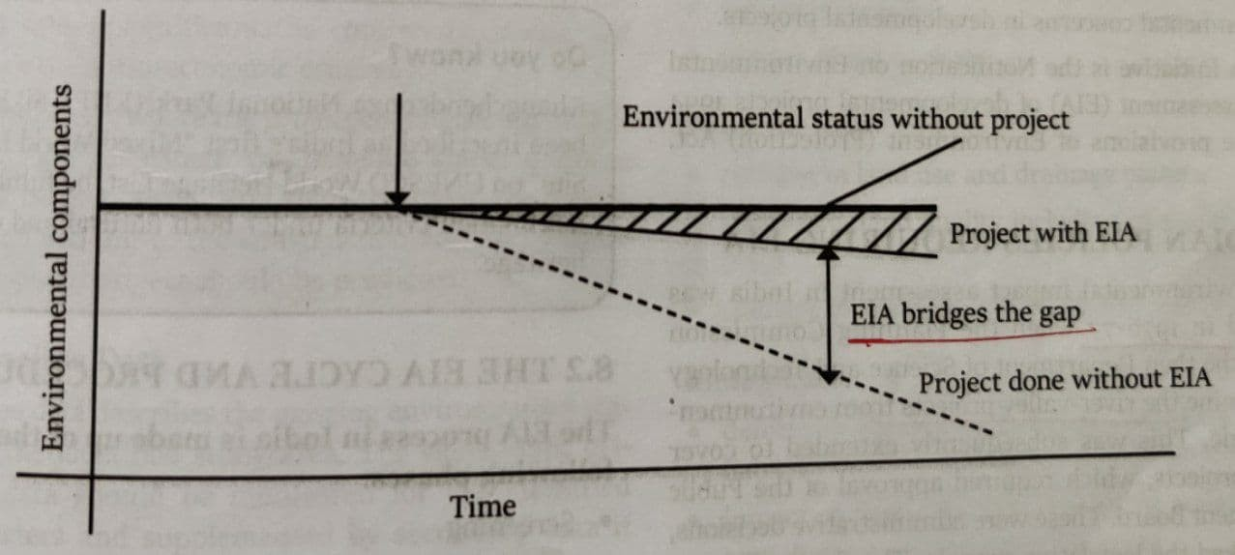

##### Rationale for EIA:

* + Aim is to forsee the potential environmental problems and address them in project’s planning and design stage
  + Importance -Gas leak at LG polymers,AP- without enc clearance for decades

##### Following are accessed under EIA

* + Fauna: NGT recently suspended hydro power project in Tawang, Arunachal Pradesh due to loss to the habitat of vulnerable black necked crane.
  + Water quality: NGT banned rat hole mining in Meghalaya.
  + Air quality: Impact of diesel vehicle in air pollution in delhi
  + Protected areas: Ban on iron ore mining in Kudremukh National Park.
  + Occupational safety: Study was conducted on health impact of plastic PET bottles. It was found to be safe and its use was allowed by health ministry.
  + Displacement: Displacement and migration of local people.

##### Procedure:

* + Screening: Under the existing 2006 law, projects are categorised into category A and B. EIA is mandatory for A and B1 where as B2 projects are exempted
  + Scoping: detailing the terms of reference of EIA process using the sector-wise guidelines prepared by MoEFCC
  + Baseline data is collected detailing existing environmental conditions
  + Impact Analysis covers various aspects such as possible impact on air, water, land, noise, animals, socio-economic impacts on humans
  + Mitigation will involve alternatives to control the impact as specifiec above. These alternatives are then ranked for selection.
  + Environment Management Plan is drawn up to list down measures to be taken for various impact. It also lists down unmitigated impacts. The plan also cover financial plan and its inclusion in overall project budget estimates. All these play an important role in monitoring of impact stage
  + Public Hearing: SPCB issues notice in 2 newspapers; People can provide suggestions, views, objections based on the executive summary of EIA
  + PARIVESH: Single window registration interface for all types of environmental clearances (ie. Env, Forests, CRZ); Unique ID is assigned to each clearance
  + 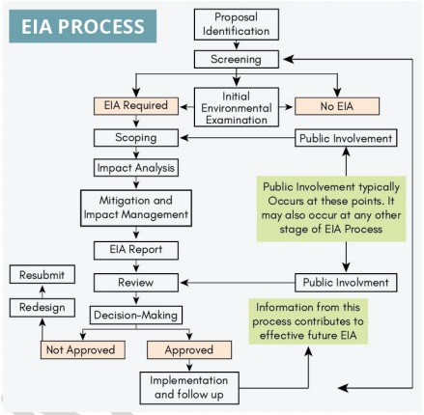

##### General Limitations

* + Team conducting EIA studies- lack of expertise, no imp to indigenous knowledge
  + EIA prepared by agency hired by project proponent- little chance that assesment is unbiased- fradaulent EIA studies- agency wants money to make project proponent happy
  + No accredition of EIA consultants

##### Changes made by draft notification

* + Evolution of EIA- First EIA norms in 1994 under EPA,1986 then 2006 EIA draft and now 2020 draft
  + Issues in draft:
    - Public consultation- It proposes to reduce the period of public consultation hearings to a maximum of 40 days, and reduces from 30 to 20 days the time provided for the public to submit their responses- will affect tribals and other who are not aware of process- lacks transparency
    - Wide discretionary powers to government- GOI can declare any area as Ecologically senstive area without consultation of public
      * Govt can tag projects as strategic not needing to give

info-can be used for wide clearances to project affecting Env

* + - Provisions for post-facto project clearance- defeats the purpose of EIA by giving post facto clearance after payment of fee (from polluters pay principle to pay & pollute principle)
    - Extended period of clearances: for mining projects (50 years versus 30 years currently) and river valley projects (15 years versus 10 years currently)- will ignore issues that come later
    - Exemptions: The new draft exempts a long list of projects from public consultation and prior clearance eg inland waterway or national highway that cuts through forest

##### Way Forward:

* + Public hearing to be done at earlier stages to ensure there is no unnecessary delay later on
  + Development of ‘panel of independent consultants’ to ensure there is no conflict of interest. Consultants need to be registered and made accountable for their reports, should not have any relation with project proponent
    - Independent EIA authority
    - National level accredition to env consulantant (EA on lines of CA)
  + Capacity building of administrative team to ensure effective monitoring of projects and adopt remedial measures
  + Automatic withdrawl of EIA if conditions are violated with strict penalty
  + NGO,local community help

### Biodiversity

##### 2018: Ecological and economic benefits of Organic State

Organic farming- production which avoids synthetic fertilizers,pesticides,growth regulators.

* Area under organic cultivation in India- 5.7 mn hectares(2015-16)
* Sikkim-fully organic state; Highest floral diversity
* Govt prog- National Program for organic production(NPOP)
* Related - Permaculture(permanent agriculture)-caring for earth,values traditional knowledge,sustainable techniques,promote organic
  + Zero Budget Natural Farming, Sustainable sugarcane initiative

##### Components:

* Rely on crop rotations,crop residues,animal manure,organic wastes,biological control of pests

##### Ecological Benefits:

* + Improves soil fertility- guarantee food security in future
  + Recycles waste within farm- less waste management
  + Reduce in crop residue induced air pollution
  + Prevent pollution of ground water and algal blooming in seas
  + Reduce the risks of human, animal, and environmental exposure to toxic materials

##### Economical Benefits:

* + Improvement in farmer’s income due to higher price for organic products
  + Improvement in BoP/CAD as there will be less dependence on imported fertilizers
  + Reduction in subsidy buden of state
  + Boon to tourism through eco-tours and farm vacations
* Need to ensure that both twin goals of global food security and conservation of the environment are met

##### Challenges faced:

* + Food security issues
  + Produce is not attractive enough when compared to chemically produced agriculture
  + The country's PA network comprising Wildlife Sanctuaries, National Parks, Conservation Reserves, Community Reserves, and Marine Protected Areas, occupies just 5.02 percent of the total area. Consequently, a large percentage of India's wildlife live outside protected boundaries
  + Various smaller species of reptiles, amphibians, insects (Wild bees, dragon flies, grasshoppers, butterflies) are taken for granted without giving adequate importance to their ecological role
  + RE is clean but still has economic footprints as well - eg: Impact on GIBI due to wind turbines; Impact of fan throated lizards of Koyna WLS due to wind farms

##### 2018: How does biodiversity vary in India? How is the Biological Diversity Act,2002 helpful in conservation of flora and fauna?

* Biodiversity: Fact - 8% world species on 2.4% land area
  + 2 biodiversity hotspots are there in India Eastern Himalayas, W Ghats
  + High species richness as well as endemism in india
* Cover how biodiversity varies across:
  + Himalays: Alpine forests, rainforests, along with species such as snow leopard, hangul, black necked cranes
  + Gangetic Plains: Flat plains with deciduous forests allow adequate space for tigers, rhinoceros,
  + North East: Tropical rainforests - with wide variety of animals such as golden langur, sangai
  + The Islands: support dugongs, hornbills, coral reefs
  + Desert Area: Shrub vegetation along with GIBI, Sarus cranes, Gharial in bordering rivers
  + The Western Ghats: Lion tailed macaque, Nilgiri tahr along with combination of evergreen and deciduous forests
* Biodiversity Act 2002(brought to realise objectives of CBD,1992-recognise sov rights of states to use their bio resources)
  + Provisions for setting up 3 tier structure- National Biodiversity Authority, State Biodiversity Board, and Biodiversity Management Committee for proper management of biological resources
  + These authorities Notify Bio-D heritage sites , advice govts on

bio-D,permission to foreign and domestic co. wanting to use India bio-d resouces and ensure F and E sharing

* + Respect and protect knowledge of local communities traditional knowledge
  + Access is provided but the benefits also have to shared with the indigenous communities

##### 2019, 1993: Social forestry and farm forestry and Integrated Farming System; Role in uplifiting rural people

##### Consequences of biodiversity in farm Integrated Farming system

* Integration of farm enterprises such as cropping system,animal husbandry,fisheries,forestry for opt utilisation of resources and bringing prosperity to farmer.
* Help sustaianable agri-minimise intensive farming which affects land
* Eg- same farm having dairy production,crops,forestry etc
* Benefits:
  + Ecological
    - Ingredients for organic farming- cattle dung for manure- use of ther recyclable material in other activity
    - Multiple uses of water
    - Agro forestry- reduce deforestaion in forest areas
    - Organic waste can help generate biogas- less dependence on fossils
  + Economic
    - Small size farmer benefit-poverty reductiom
    - Steady income in all seasons due to diversification of activity as well as crop diversification
    - Risk coverage in event of crop failures
    - More emp to tackle disguised employment

**Social forestry** refers to the management of forests for the benefits of local

communities. It includes aspects such as forest management, forest protection, and afforestation of deforested lands with the objective of improving the rural,

environmental, and social development.

**Farm Forestry** means growing trees on farmlands for commercial purposes or for variety of non-commercial purposes like groundwater control, prevention of soil erosion, prevention of polluting nutrients in the soil etc.

##### 2012: Plant genomes: Role in hunger and env

* International seed treaty
* GM crops debate- harming env? Solving food insecurity

##### 1982: Steps to preserve the endangered species? Succeses? 3 animal unique to India?

* WPA 1972: provides for the protection of wild animals, birds and plants. Various kinds of protected areas such NP, WLS, Conservation reserves,
* National Wildlife Action Plan: NWAP 2017-31 under which there are 250 projects to conserve wildlife for the next 15 years. Also contribute to SDG 31
  + The key strategic changes in the new plan is adopting a “landscape approach” in conservation of all the wildlife. ie. now the strategies would be based on the landscape of the region that may not be limited to a national park and WLS reserve forests alone
* Convetion for Mig Species (CMS) provides a global platform for the conservation and sustainable use of migratory animals and their habitats
* Unique: Greater One-Horned Rhinoceros, Asiatic Lions, Nilgiri Tahr

##### Misc Issues in news wrt conservation of animals:

* Assam, WB and OD account for almost half deaths of man and elephant both; Main cause of elephant death is**Electrocution** (and *second* is train accidents)
* Despite ban on drone cameras, usage is hurting wildlife like birds, elephants in Niligiri
* Reports have shown that anthropogenic causes has led to restricted movement of **Tiger**; Restricted movement reduces **genetic exchange** and increases the

*probability of extinction*

* FATF estimates the illegal wildlife trade to be $23 Billion per annum (comes to 1.71 lcr rupees 😵)
* *Mahatma Gandhi said that the greatness of a nation can be judged by the way its animals are treated*
* Human-induced environmental changes reduce biodiversity resulting in new conditions that host vectors and/or pathogens.
  + By disturbing the delicate balance of nature, we have created ideal conditions for the spread of viruses from animals to humans.
* India should leverage the over 2 lakh biodiversity management committees to promote mass biodiversity literacy
* **Mobile hospital** initiative by Australia to treat animals affected by bushfires; Same model can be adopted by India for human-wildlife conflicts
* SC said the re-grassing is mandatory after mining; cost must be borne by licence holder so that biodiversity is given a chance; Bench headed by CJI Bobde

### Climate Change

##### Stats & Statements

* COP 25 highlighted that its is no longer a climate crisis but a climate emergency
* IPCC special report - Need to limit global warming to 1.5 degree (Climate Action Tracker shows that current emission are on track towards rise of 2.4 degrees)
* 5th most vulnerable country to CC as per Global Climate Risk Index 2020
* ‘Change is the Law of Nature’
* **Future of Earth 2020** Report highlighted five risk factors that may lead to global systemic crisis
  + Failure of climate change migration and adaptation; Extreme weather events; Biodiversity loss and ecosystem collapse; Food crisis; Water crisis

##### What is contributing to CC:

* GHG emission are leading to rise in temperature ~ avg 0.7 degree rise last century
  + such as methane, CO2 (deforestation), NO2 (fertilizers)
* Land degradation: Deforestation, sand mining,
* Chain of events
  + Burning FF- inc GHG-Global warming-CC-melting glaciers-seal level rise-submergence of coasts-large scale destruction of Bio-D,impact monsoon etc
  + As oceans get warmer, it leads to release of CO2 into atmosphere (as oceans act as largest carbon sinks)

##### Impact of CC:

* Agriculture
  + Impact due to affecting water,amount of solar radiation,prevalance of pests(locusts)
  + Different impact on temperate(benefit) and tropical crops (negative impact)
  + More land for agri due to thawing of snow but decrease in coasts due to sea level rise
  + On Indian Agri
    - Rain fed agri- studies predict decline in summer rainfall by 2050’s,Erractic monsoon
    - Inc use of fertilizers-more GHG-vicious cycle
    - Locusts affecting food security- Raj etc
    - Disasters- floods ,droughts affecting agri
* Water stress and water insecurity
  + Food insecurity due to water stress
  + Decline in glaciers- less water in long run- affect seasonal flow (more than 1000 new lakes formed in Swiss Alps)
  + Floods and droughts at the same time
  + Increased salinity in coasts due to sea level rise- affect fresh water
  + India
    - Gangotri glacier retreating about 28m per year- affect water in rivers in long runs with floods now, river changing courses frequently- affect people of Ganga delta
    - Water polln, erractic SW monsoon- scarcity for domestic,agri(main impact as 83% water use in agri),industrial along with population increase
    - More impact on developing C
* Sea/coastal
  + Sea level rise- affect island and coastal states- CC induced migration
  + warming seas- more intense cyclones- Amphaan
  + Coral reefs,FW fishes too saline sensitive
  + Oxygen dissolved in the water is already less when compared with air (water has 10 ppm where as air has 200,000 ppm of O2). With more and more pollution this small portion of dissolved oxygen is getting reduced; Concentration of dissolved oxygen of water below 6 ppm inhibits the growth of fish & plants
  + Affect magroves,wetlands
    - Indian coastal states
      * Maha, goa- lose land, damage infra- eg mumbai fort area submergence,goa-famous beaches
      * Sea water percolation-affect FW due to salinity- water scarcity
      * Orissa coast-worst cyclones, affect turtles and other species, Sundarbans vulnerable
* Biodiversity
  + Flora fauna extinction (as 99% of animals and all plants are conformers ie. they cannot maintain suitable internal temperature when outside climate/env changes
  + Heavy flash floods induced by CC destroy fragile systems storing illegally farmed invasive alien species of fishes (such as Amazon catfish, Arapaima,etc) which gets released into natural ecosystem → destroying local diversity
  + Impact on marine major
    - India
      * Himalayan BioD-snow leapord
      * Desert species affect- eg floods in barmer (rajasthan) in 2006
      * Coral bleaching
  + Unusual movement of moths & butterfly → being found at heights much greater than their usual range at Himalayas
* Health
  + ILO reported there will be loss in productivity due to heat stress
  + Large scale migration - Climate change led to the displacement of 2.7 million Indians in 2019 (highest in the world)
  + Floods- mosquitos breeding-dengue,malaria,japanese encephalitis, water boren diarrhoeal
  + Life expectancy in India has gone down by 2.6 years due to deadly diseases caused by air pollution as per report by CSE
  + Rising GHS’s-Ozone depletion- skin cancer
  + Food insecurity-malnutrition
  + Environmental migrants and refugees
  + India
    - More impact on poor,women than others
* Himalayas/Glaciers
  + The Third Pole of the world is facing reduced snowfall levels
  + The glaciers are melting at a faster rate due to elevation and reduced albedo affect- excessive melting can make entire ganga plain with 30 cr people unlivable
  + Impact Monsoon
  + Drying springs in long run
  + Glacier Lake outburst floods
  + Affect Hydropwer generation
  + Biodiversity,Agri

##### India’s Efforts

* National Action Plan on Climate Change (*NAPCC*) - SF = SHE-WASH-G (use these dimensions to frame answer)
* Energy Efficiency measures: PAT Schemes, GRIHA
* Direct adoption of BS VI norms
* National Afforestation Programme for afforestation and reforestation of degraded forests
* FAME Phase II project for EVs. ‘Switch Delhi’ Campaign to promote EVs
* Swachh Bharat Mission for SWM
* National Policy on Biofuels – 2018 which aims at taking forward the indicative target of achieving 20% blending of bio-fuels by 2030
* Financing Mechanisms:
  + National Adaptation Fund on Climate Change was established in 2015 to meet the cost of adaptation to climate change for the State and Union Territories that are particularly vulnerable
  + CAMPA Funds, Promotion of Green Bonds
* International Collaborations:
  + INDC under Paris Deal: 2 Quantitative goals
    - Reduce emission intensity by 33% below 2005 levels
    - Achieve about 40 per cent cumulative electric power installed capacity from non-fossil fuel-based energy resources by 2030
  + International Solar Alliance
  + REDD+ Reducing emissions
* Agriculture: Soil Health Card, National Initiative on Climate Resilient Agriculture Indian succeses:
* Climate change perf Index by germanwatch - India 9/57 (no top 3)
* Champions of Earth award by UNEP- highest env honour Issues in mitigating CC- Greta thunberg
* International differnces- USA outlook, diff diplomacy
* Neglect of C but DR
* Climate refugees issue- island states
* Basic demerits of developoment Other issues:
* To adapt to rising temp we will **adapt** via cooling systems such as ACs, but if they are inefficient it can act as bane for our **mitigation efforts** (very few households purchase 4 or 5 star AC) - We need passive cooling alternatives such as energy efficient building design
* Criticism of Paris Agreement:
  + NDCs did not add up to limiting the rise of global temperature to below 2°C
  + At 1.5°C, 70%-90% of coral reefs across the world would die. At 2°C, none would be left.

##### Way Fwd

* Resorting to carbon taxation as suggested by IMF: It not only has environmental benefits but can also enhance revenue for the govt. (a $35 tax on CO2 per tonne can generate revenue equivalent to 2% of GDP through 2030)
* Indian corporations can contribute to sustainable future by **Green Contracts** which involve green tenders, green obligations, green qualifications (contracting parties decide to cut down emissions at diff stages of contracts)
* Using **Environmental Tax** (eco tax) mechanism to raise funds to fight climate change - eg: Differential taxation on vehicles based on fuel efficiency, supporting env friendly activities, eliminating existing subsidies that harm environment (eg: agri subsidies, kerosene subsidy, etc)
* With climate change now becoming climate emergency, inaction is no longer a choice. The future of present & future generations is at stake

##### 2014: Relevance of carbon credits, current status and future mechanism

Carbon markets- allow for buying and selling of carbon emissions with the objective of reducing global emissions . Currently an unfinished agenda in Katowice, Poland as well as Madrid(COP25)

##### Relavance

* India said it would reduce its emissions per unit of GDP. Only the developed

countries have included absolute emission cuts in their action plans. Yet, there is scope for absolute emissions reductions in developing countries too.

* + Over 90% of the accumulated GHG has come from the rich & industrialised countries over the past 150 years
* For example, a brick kiln in India can upgrade its technology and reduce

emissions- if a developed country is unable to meet its reduction target, it can provide money or technology to the brick kiln in India, and then claim the

reduction of emission as its own.

* Alternatively, the kiln can make the investment, and then offer on sale the

emission reduction, called carbon credits. Another party, struggling to meet its own targets, can buy these credits and show these as their own.

* Carbon markets also existed under the Kyoto Protocol, which is being replaced by the Paris Agreement next year(2020)-
  + Article 6.2 of Paris agreement enables bilateral arrangements for transfer of emissions reductions, while ensuring that they do not double-count the reductions.
  + Article 6.4 talks about a wider carbon market in which reductions can be bought and sold by anyone.
  + Article 6.8 of PA provides for making ‘non-market approaches’ available to countries to achieve targets. It is not yet very clear what these approaches would constitute, but they could include any cooperative action, like collaboration on climate policy or common taxation, that are not market-based.

##### Current status

* The main tussle is over two or three broad issues — what happens to carbon credits earned in the Kyoto regime but not yet sold, what constitutes

double-counting, and transparency mechanisms to be put in place.

* Developing countries have several million unsold CERs (certified emission

reductions), each referring to one tonne of carbon dioxide-equivalent emission reduced, from the Kyoto regime. Under the Kyoto Protocol, only developed

countries had the obligation to reduce emissions.

* In the last few years, several countries walked out of the Kyoto Protocol, and those that remained did not feel compelled to fulfil their targets. The second commitment period of the Kyoto Protocol (2012-20) never came into force. As the demand for CERs crashed, countries like India and China were left with

projects generating CERs with no one to buy them.

* + India has about 750 million unsold CERs and, along with other similarly placed countries, wants these credits to be valid in the new mechanism too. Developed countries are opposing it on the ground that the rules and verification procedures under the Kyoto Protocol were not very

robust; they want the new mechanism to start with a clean slate.

* The second issue is that of double counting- important to ensure that in this

process, credits are not counted at more than one place; whoever sells carbon credits should not simultaneously count these as emissions it has reduced.

* + The developing countries argue that the country that reduced emissions should be able to show it even after selling the credits, and that adjustments should be made only for subsequent transfers, if any.
* Carbon Tax in India: GST Compensation Tax Rs. 400 per tonne on coal

##### Future

* Carbon markets are not essential to the implementation of Paris Agreement. But with the world doing far less than what is required to prevent catastrophic impacts of climate change, the markets can be an important tool to close the action gap.
* Developed countries and many civil society organisations say they would rather have no deal on Article 6 of the Paris Agreement than have a bad or

compromised deal that would allow transition of Kyoto regime CERs or any kind of double counting. Some developing countries, on the other hand, prefer to have an agreement finalised in Madrid.

**Current Updates and Value Additions**

* Progress made by India:
  + 200% inc in Ramsar sites, LiFE, Tigers, **SUP ban, 37 crore LED bulbs**

##### under Ujala Yojana;

##### IFC recognised India as the only G20 nation in line with 2 degree cel warning

* Committees:
  + **CC** (High level IMAC - **Intern-min APEX Cmt, Quote MK Ranjitsinh Case**), **Coastal (Shailesh Nayak-CRZ norms**), ⭐**WGs/Biodiversity**

(Madhav G-64%, Kasturirangan-37%), **Water related** (Mihir Shah), **Stubble burning** (Justice B Lokur Cmt), Microfinance (Malegaon Cmt), **Ganga Prahari - Guardians Of The Ganga** (**Community involvement**), **TSR Subramaniam Committee** (1. New Umbrella Law by summing Envt laws 2**. National Envt Management Authority** 3. **All India Environment Service** 4. Review six major environmental laws)

##### Case Law: Mk Ranjitsinh & Ors v GoI 2024

##### Right to be free from adverse effects of climate change

##### Balancing conservation of GlB and Renewable energy

* Common WF:
  + GEP in Uttrakhand, 2 lac BD Mgmt Cmt to raise awareness; Circular

Economy; EIA in right manner; Local indigenous knowledge and participation, Miyawaki Method

* **Terms**:
  + **Water/carbon footprint**; **Ecosystem services** (provisioning serv,

regulating, cultural, supportive services), **EIA to Env & Soc Impact Assessment**; Intergenerational equity; **Bio-accumulation**, **BOD**, **Eutrophication**, Green contracts, Energy self reliance

* Data:
  + **IPCC reports** indicate that Himalayan glaciers could **lose up to 80% of**

##### their volume by 2100 if global warming continues unchecked.

##### Circularity Gap Report 2023 (7.2% GDP)

* + **CO2** emission (per capita vs global, 1**.9, 4.7 MT**)
  + **2.33 million hectare** of tree cover lost since 2000 (**Global Forest Watch report**)

##### NCD (2 out of 3 deaths due to NCD)

##### Climate change (Eco impact by RBI report - Loss 3-10% annually by

**2100** under different scenarios);

* + *India needs* ***$10.1 tn*** *to achieve* ***Net Zero by 2070***
  + **Current INDC** (emission gap report, 3 degree), **Sea level rise** (4.5 mm pa), **River Pollution** (Ganga, 12k litre total discharge, vs 4k litre treated), **GW table** decrease pa 0.3 mtr pa, **17% world death due to air pollution** in India (**Lancet Health**), **Climate Change Perf Index 2024 7th** Rank even vulnerability 7th (use it in disaster also);
* Climate Change
  + COP28 Outcomes:
    - Launch of Global Renewables and Energy Efficiency Pledge (India not a signatory); **Oil and Gas Decarbonization Charter**; **Conclusion of First Global Stocktake of the Paris Agreement**; **Operationalization of loss and damage fund**; **Global Green Credit Initiative (GGCI) by India**; COP28 UAE Declarations on Agriculture, Food, & Climate

##### Issues: Failure to agree on rules for global carbon market;

**Promotion of Marine geoengineering technologies like CCUS** in COP28, ignores the harm they pose to marine environment; India’s concerns at COP28 + general ones (Refrained from signing COP28 Declaration on Climate and Health - as could hinder ability to meet med demands; **Reiterated that cuts must be on all fossil fuel, not just Coal** - **hence refused to sign Green energy pledge; CBDR-RC must be maintained; Greater share of carbon budget for developing, CBAM issue, Definition of climate finance is unclear**

* + **Initaitves at COP27**: Mitigation work programme, **L&D Fund**, **Mangrove Alliance for Climate (MAC), Koronivia JWA**

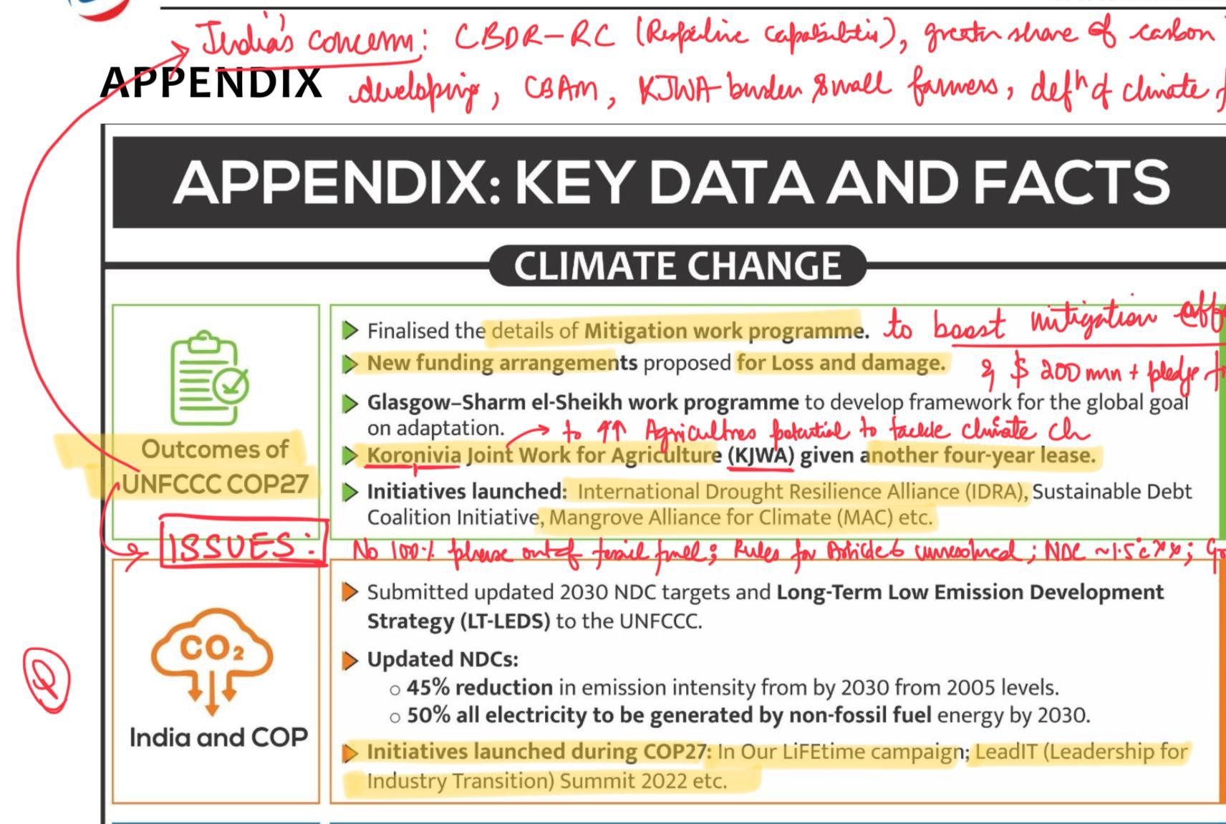■

* + **Whole of the society approach** is the need of the hour to address the impending climate emergency
  + **WF to tackle CC:** Countries should **increase climate commitments** (like **India did** via Panchamrit); **Decarbonise economy** via **carbon markets/carbon tax/CCUS** (Recent report by NITI Aayog); Climate-smart agriculture needs to be adopted water resource use efficiency; High-level inter-ministerial Apex Committee, 2020 (IMAC) set up by India to implement climate committments, **NCAVES**, GEP by Uttrakhand, Social Forestry
* Green Credit Program launched by MoEFCC
  + **Generated under EPA’86** (***unlike carbon credits which are in Energy***

***Conservation Act, 2001***; Focus on **indv/community action** (***rather than industry*** focus of energy conservation)

##### Market-based mechanism to incentivise environment positive actions by different stakeholders

##### Foster Mission LiFE (Tree plantation, Water Management, Mangrove Conservation, Sustainable Agriculture)

* **Ministry Of Power** (MoP) announced reforms in **Carbon Credits Trading Scheme** (CCTS) - **Bureau of Energy Efficiency (BEE) to develop the standards and register the project**; **BEE would validate carbon credits (no need to go to overseas standards agencies** to validate their carbon credits; Foreign projects can choose India for certification)
* Central Consumer Protection Authority (**CCPA**) has sought public comments on the **proposed Draft Guidelines on Prevention and Regulation of Greenwashing**
* Climate Finance Initiatives: **NAFCC (central sector scheme for funding)**, **Sov Green Bonds**, **PSL lending**, **Carbon Credit trading** schemes, REC
* **NCAP** - Target: Achieve **reductions up to 40%** of PM10 and PM2.5 concentrations **by 2025-26,** base year 2017
* Water (Prevention and Control of Pollution) Amendment Act, 2024
  + Parliament passed the same -using Article 252 (2 or more states)
  + **Chariman of SPCB - CG can prescribe** (unlike SG nomination in prev Water act, 1974)

##### Guidelines for exemption by CG (unlike SG before)

* + Decriminalised offences, have penalties now upto 15 lac (earlier act had imprisonment)
  + +ves (EoDB, Bal dev and env, reduce regulatory burden); -ve (Penalties are ineffective due to cultural reasons; federalism issues)
* Recently, **NITI Aayog released a document** on water trading mechanisms to

##### promote the reuse of treated wastewater

* **Parliamentary Standing Committee has recommended** the government to prepare a **practical action plan with clear timelines** to put a check on **destructive activities in Himalayan Region**
* **E-waste issues**: **85% in unorg** sector; **Quantum is huge** vis-a-vis recycling infra; **Shift from developed to developing**; **Short life products** with ltd repair WF: Use **CSR**, **Skilling** of informal workers; **Co-locate e-waste centres in industrial clusters**
* Major environmental movements: **Chipko** (Amrita Devi Bishnoi); **Silent Valley**

in Kerela; **Appiko** in KR; **Narmada Bachao**

* Roof top solar: PM Surya Ghar Muft Bijli Yojana

##### Incentives 30-78k; Collateral-free low-interest loan; Model solar

**villages** for role model; provide **free electricity up to 300 units** every month for **one crore households**; **Net-metering** concept

* + Currently, India has installed **11 GW** of **rooftop** solar capacity →

**Addition of 30 GW** of solar capacity through RTS by new scheme

* + Side Note: Key Strategy of Int Solar Alliance: Guided by the ‘Towards 1000’ strategy; **OSOWOG**
* Cheetah Relocation:
  + **1952** extinct (**make 5 sec map SA/Namibia to India at Kuno NP**); Under

Project Tiger thus **led by NTCA**

* + **In favour**: Model for **future restoration (Gir, Rhino**, bison to SL); Ecological balance (menance of neelgai, reviving grassland); Cultural values (mentioned in Yajurveda, restore ecological cultural values); Keeps **ecosystem healthy** (hunts on old/weak members of the preybase as runs and chase); Eco-tourism; **Global meta population** can aid in conservation; **Boost India-Af ties** (s-s coop);
  + **Against**: Allegation of being **kept in dark by South African scientists**; **6 cheetahs + 3 cubs** born in India dead by 03-Aug-23; for a keystone

species; Competition among other big cats - prey-predator dynamics;

**Animal rights (Stress,** anxiety); **Expensive profligacy** due to poor success rate; **Human-wildlife conflict (cheetah hunt in the day**); **Small enclosures/parks for keytone species**

* + **WF: Need annual review/monitoring**; **In-house training** of forest officials/**veterinary** team; **C**ommunity participation and awareness
  + **Concl**: 11m is too early to pass a judgement as project is a LT; **SC said Project must be moored in “scientific understanding”**
* **National Green Hydrogen Mission**
  + with an outlay of ₹19,744 crore from FY 2023-24 to FY 2029-30
  + **Features**: **5MMT** Green H2 by 2030; Under **SIGHT give incentives for dom manuf of electrolyser** and production of H2; Facilitate **R&D via PPP**; **Pilot projects via Green H2 Hubs**; **Skill development (create 6 lakh** green jobs)
  + **Green H2**: Pros (Import dep and saving on CAD, Green jobs, **Export potential**, **Decarbonise Heavy Industry**; **Energy Storage-become easy,** Low carbon footprint); Cons (H2 storage and transportation are prone to **leakages and corrosion**; Requires **huge amounts of water owing to the poor efficiency** of the electrolyzers; Expensive; Green H2 is highly **volatile and flammable** element, **Infra issues-cryogenic materials**);
  + **WF:** H2 **mixed with natural gas** can be used in existing infra (as done by GAIL); **Partial expemption for grid charges/**taxes for electrolyser; **Store in salt caverns;**

##### Concl: Overall allow us to become energy self-reliant by 2047/Panchamrit Targets

* Forest Conservation (Amendment) Act 2023
  + **FCA 1980**: States to take permission of centre for dereservation of forest

or using forest for non-forest purposes

* + **Changes after FCA 1980**: Diversion slowed due to regulatory process; Diversion to dev projects increased post 1991 but reduced diversion to agri land

##### Arguments by Govt:

* + - **Afforestation o/s forests** affected due to **confusion in definition** of forest, thus an hindrance to NDC target **2.5-3 bn tonne** CO2 sink
    - Need dev of tribals - **enhance ease of living (bill exempts areas of 0.10 ha for public amenities**edu/hosp/rail)
    - Needed for **faster clearance**/warfare (earlier border left underdev to make diff for enermy to come inroads)
    - Devt of **naxal affected areas**
    - **Promote eco-tourism** through **zoos/safaris** (Project Tiger succeeded as ppl came to visit) - **as permitted activities** now inlcude zoo, eco tourism

##### Issues:

* + - 1. Greenwashing/Greengutting (pro env lang but undermine regulations)
    - 2. **Nullify's Godavarman case judgement** (Made natural forest under act (about 25%) which were being eroded without protection- **called deemed forest**)- now reversed again to reserved forest only - might allow Niyamgiri forest Vedanta bauxite to now be exploited as majorly unrecorded);
      * **Narrowing the definition could leave** nearly 2 **lakh square kilometres of forest land** from the ambit of 'forest'
    - **3.** Forests under **concurrent list by 42nd CAA - states right** affected
    - 4. **Undermine tribal rights (NCST chair resigned** as oppose trampling rights of adivasi) (Niyamgiri case- SC said local community have a say in projects the cut forest)
    - 5. Exemption to linear projects within 100km of borders for national sec/strategic project (which is vague, **threaten Ecologically Fragile Areas** across borders);
    - 6. Compensatory afforestation- **window dressing - Loss of Nicobar forest led to plantations in Haryana** or Creation of zoos/safaris counted as compensatory forestry purpose (greenwash)
  + **Concl**: Any diversion of forest land should be done to ensure sustainable development; need wider consulation and protection of right of people;

##### ⭐ SC recently directed the Government to follow the definition of

**"forest" as laid down in T. N. Godavarman judgment** - until records of all lands on which new provision will apply is prepared by SG/UTs

* Hydrosphere
  + Example: Coastal Mumbai fort submergence, **Microplastic in Ganga**

**(NGO Study)**, **Great Pacific Garbage Patch (3x France)**, Toxic foam in Yamuna, **Virtual water exporter;** Deadly Trio (Ocean acidification, ocean warming, and oxygen loss - key words - **dead zones, eutrophication**)

* + WF: **London Convention**, **Bioremediation**, National water

policy-integrated approach; Ecological flow, Mihir Shah committee report

* Atmosphere
  + Example: **CSE Report 2.6 yrs**
  + WF: Right to clean air (Article 21), W2E plants (monetise waste), **CCUS Tech**
* Lithosphere
  + Example: **Ksan Rat hole mining**, Destruction of Aravalis (sand construction mafia)
  + WF: SC-regrassing mandatory after mining, **Miyawaki Method**, Low land ecosystem management in Burkina Faso
* Waste
  + Example: Death of garbage collectors in delhi (BM waste)
  + WF: **Cape Nature Stewardship Program (successful PES-conservation**, poverty alleviation), Garbage Cafe Ambikapur, E-waste clinic, **Zero liquid discharge**, Bioplastics, Municipal Bonds, **Educate 3Rs,** Decentralised SW Mgmt plan @ RWA

## People’s Health, Women, Refugees

* + Example: ILO Low productivity, Blue baby syndrome (N2 leaching)
  + WF: Nansen Initiative/New York declaration for refugees, Climate Justice (framing CC as an ethical and social issue rather than just environmental; **Distributional**-of costs, **Inter-generational**, **Recognition**-that countries affected differently)
* On ﬂora and fauna (apart from land)
  + Example: NGT suspended hydel project in Arun P to protect blacked

necked crane (EIA)

* + WF: Landscape based approach in Wildlife Plan

## Wildlife protection Amendment Act 2022

* Schedules reduced to 4, **Management Authority** (*for issuance of permits for*

*trade of specimens for compliance to CITES*) **Gram Sabha consultation if sanctuary in Sch V or FRA**; **Inc penalties**, Transfer or Transport of live elephant exempted; **Relaxations for film making,** grazing, in sactuary - No need to refer image

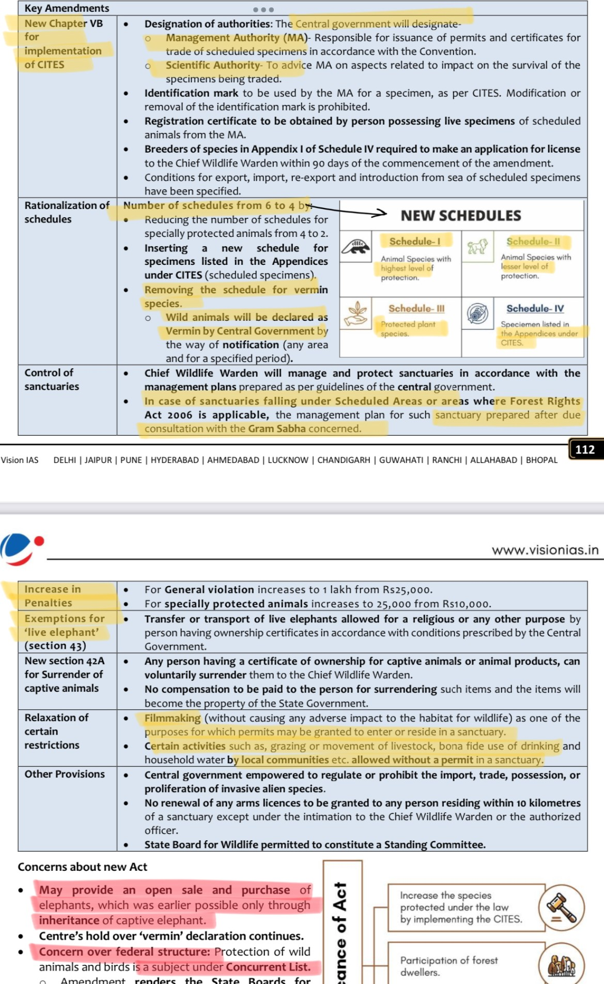

By Madhav Agarwal (<https://t.me/madhavagrawalair16>)

By Ratnesh Agrawal (Insta: <https://www.instagram.com/ratnesh13/>)

## Delhi Pollution:

* + During peak pollution periods, Delhi's AQI often crosses 400, indicating

'severe' levels of pollution

* + Causes of Air Pollution
    - Vehicular Emissions: Delhi has 12.25 million vehicles, a significant increase from 3.4 million in 2000, **contributing 70% of the pollution**.
    - Industrial Emissions due to **coal**: Factories in the NCR burn 1.7 million tonnes of coal annually.
    - Construction Activities: Continuous building projects **increase dust and particulate matter**.
    - Waste Management: Daily, 11,000 tonnes of waste are generated, with inadequate disposal methods exacerbating pollution (**burning of waste**)
    - Geographical Factors: Calm winds during winter trap pollutants, forming smog.
  + Health Impact

##### Respiratory Diseases: One in three schoolchildren in Delhi suffers from asthma.

* + - Life Expectancy: Air pollution reduces the average life expectancy of Delhi residents by 11.9 years.
  + **Solutions**: **Ensuring factories** install **purification devices**; Expanding and **improving metro and bus networks**; Converting **vacant parking lots into green spaces** to absorb pollutants; **Community Involvement**: Promoting **carpooling**, reducing firecracker usage, and minimizing air conditioner use; adoption of electric vehicles; Regional cooperation

## COP15 of CBD - “Kunming-Montreal Global Biodiversity Framework” (GBF)

* + Follow up to Aichi targets were till 2020, **no single country achieved all**

##### 20 targets

* + GBF includes 4 goals and 23 targets for achievement by 2030; (2 countries China, Canada led thus 2 names)
  + Key Targets: **30x30 Deal** (**Restore** 30% degraded ecosystems, **Protect** atleast 30% land/ocean/coast by 2030); Stop the extinction of known species and by **2050** reduce tenfold the extinction risk; Reduce global footprint of consumption by 2030; Reduce pollution risks and negative impacts of pollution from all sources; Tackle climate change through nature-based solutions; Green up urban spaces; Others (aim to **ensure USD200 billion per year)**
  + India argued: **Need dedicated fund** for post 2020 targets (**currently GEF for all** UNFCCC, UNCCD), Uphold **CBDR**
  + **Unique aspects of GBFF**: Global Biodiversity Framework Fund managed by GEF is unique as its action oriented and focsued on Indigenous-led conservation projects
  + ⭐ Use above deal as conclusion with Biodivesity Theme
* **Loss & Damage**: Historic fund setup at **COP27** through the **efforts of G77 + China** (representing 80% population); Warsaw COP19 started it
  + **Issues: Fund inside or o/s UNFCCC** - G77 wants former; **Distinction of particularly vulnerable countries can divide developing**, **Who will pay? +** omits reference to historical liab + EU wants China to contribute + Small Islands wants India/China to pay-in; Inclusion of unreliable pvt sector as donor

##### COP28 climate conference in Dubai, officially operationalized the loss and damage

##### India’s stand on fund: Strong supporter of the fund and opening up L&D funds for developing nations and not limit it to small island and least developed nations

# Mission LiFE -

* + Use and dispose to circular economy, **Pro-Planet People**, **Jan Andolan**,

Leverage culture (sun-drying of clothes), **Sustainable mobility** (**elec car**, cycle), **Sustainable food** (**organic, reduce meat**), **Eco-design of buildings**, Avoid SUP, **If 1 out of 8 bn adapt env friendly lifestyle** then global emission **reduce by 20% (UNEP);**

##### Atleast 80% of all villages and urban local bodies to become

##### environment-friendly by 2028

## Carbon Border Adjustment Mechanism (CBAM)

##### CBAM requires importers to pay a price linked to the average

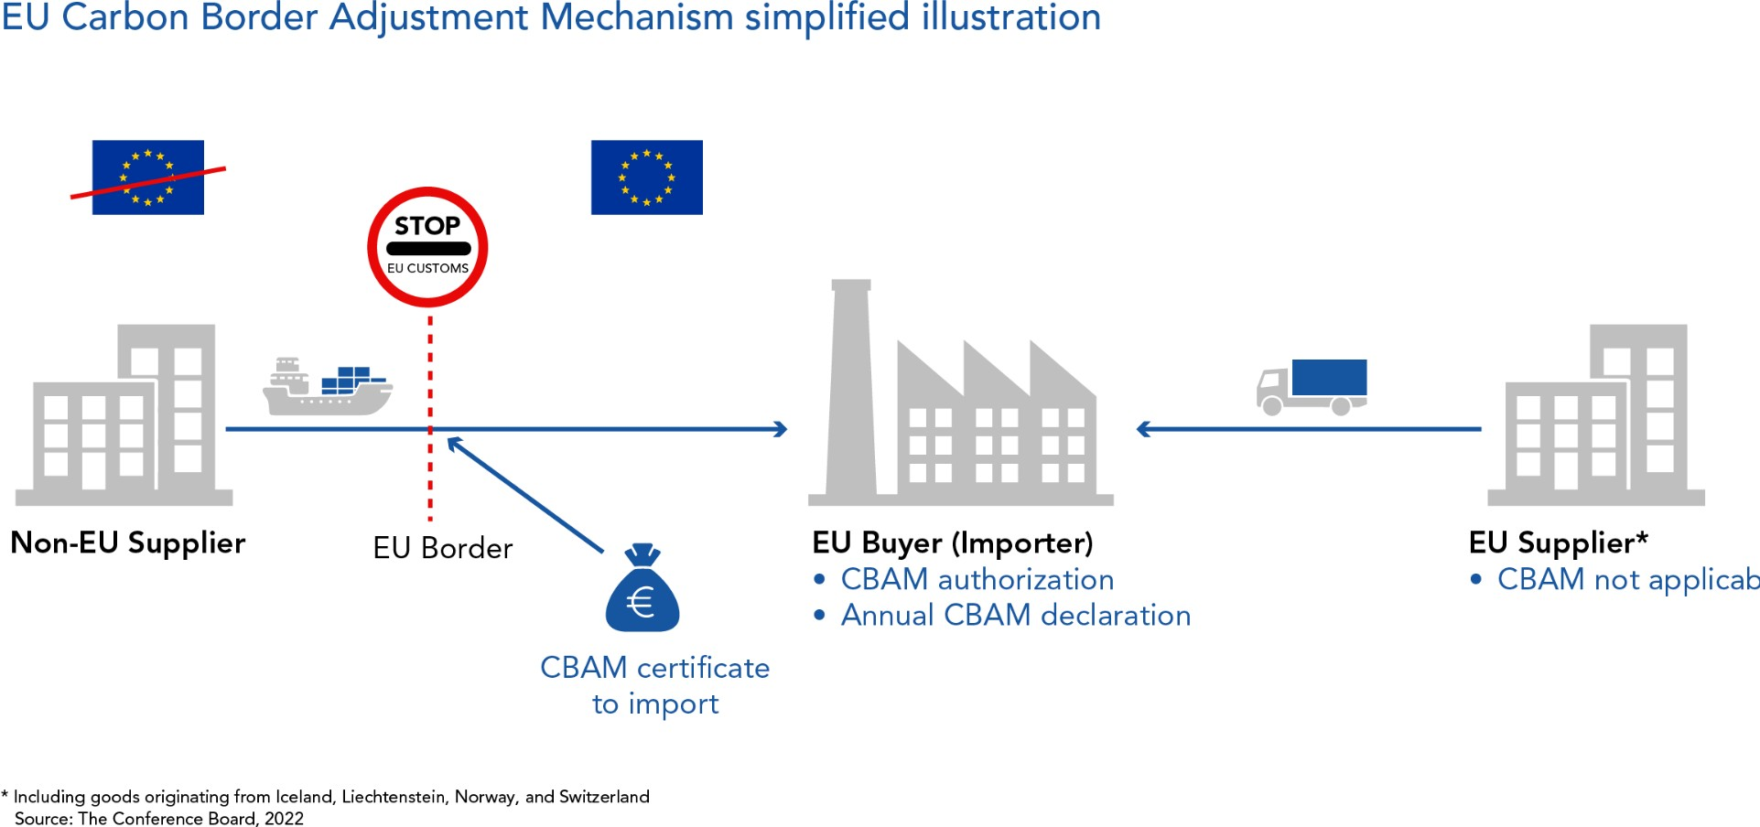**emissions cost** under the EU’s ETS. If the imported products have already paid an explicit carbon price in their country of origin, a **reduction can be claimed**

* + **Signif**: Incentivise **Non-EU to inc climate ambition**; **Prevent carbon leakage** (EU firms relocate to countries with less strict emission norms); **Upholding polluter pays**
  + **Issues:** Developing countries argue that revenue collected from it is invested back in EU itself; More than **quarter of India's export predicted** to get affected (**EU big partner**); **Violated CBDR**; **Diff to measure carbon** prices; **Economic risk for global south** + cost passed to consumer
  + **WF:** Need **some carbon market system with taxes in India** to incentivize shift towards Green; **Need Stds by BEE (recently brought)** to measure carbon embedded; **Bilateral resolution with EU**; Win-Win approach: Invest revenue back in developing countries will help solve both issues together

##### Eg: of Carbon Market & Trading: RE Certificates (REC), ESCerts, Carbon Credit Trading Scheme

# National Water Policy 2012:

* + Efficient utilization of water; Minimizing wastage and ensuring equitable

distribution of water; Encouraging research and development in the water sector; Monitoring and assessment of water quality

* + **Namami Gange** was recognised by **UN** as among **top 10 world restoration flagship programs → 170+ STPs,** Gangra Prahari, Arth Ganga
  + **Tribals** in MP's **Shadol** Division used **trenching** (**digging small drains from field to wells**) to recharge more than 100 well during rains (plan to replicate for 800 more wells)
  + Turtles playing key role in Cleaning Ganga - NMCG
  + **One Water Approach** - believes that all water has value, regardless of its source (thus use stormwater, waste water, land use affect water cycles)

##### Q.2) What do you understand from green growth? With special reference to the budget 2023-2024, discuss various government measures to propel green growth in the country.

* + Approach: Introduce the answer by explaining green growth. In the body of the answer, discuss the benefits of green growth via diagram). Next, discuss various government measures for propelling green growth in the country. Lastly, suggest ways to make the measures for green growth more effective. Conclude the answer by impressing on how green growth can balance the socio-economic needs of present generation with need of sustainability for the well-being of all in the future.
  + **Signif**: Industrialise without carbonining and reducing carbon handprint; Food security without causing harm to nature; creating Green Jobs to realise DD
  + **Methods**: Battery Energy Storage Systems, Green Credit Programme (beh change, incentives), Agriculture [PM-**PRANAM**, **10,000** Bhartiya Prakritik **Bio-Input Resource Centres** (**BIRC**), Boost to NF]; **Green Jobs**

##### (MISHTI via CAMPA & MGNREGS) & Amrit Dharohar (wetlands); Green

Hydrogen Mission (5 mmt target); Leadership via ISA; Panchamrits (Glasgow summit)

* + Measures to make green growth more effective: Facilitating technology and fund transfer; innovation. E.g., linking academia, start-ups, and industries; Circular Economy; W2Wealth

## Project Tiger:

* + Centrally **Sponsored** Scheme for **in-situ conservation of tigers**;

Implementing agency is NTCA; Started with 9 TR

* + **Activities**: 53 TRs**; Core-buffer strategy** (core area free from humans); M-STRIPES**; Spcl Tiger Protection Force; E-bird project** for drone survelliance;
  + **Success**: Today at 75 yrs, approx **75% tigers** are in India; From 18k sq km & 9 TR area under conservation to **75k sq km** with **53** TRs; Overall project generates 45 lakh man days pa; Help support SHGs too; Doubled tiger **4 yrs in advance** at 2018;
  + **Constraints**: **Retaliatory killing** in human-wildlife conflicts (**Avni tigress**); **Habitat loss/CC/land**degradation; Low capacity of local forest officer; Reducing prey base
  + **WF:** Need **trans-boundary coop** with **BG** for Bengal tiger; **Tiger corridors**

## Human-Wildlife conﬂict (HWC):

* + Reasons (**Invasive Alien Sp reduced food**; Stochastic events like forest

fire/flood push them out; Habitat fragmentation-only 5% area protected; reached carrying capacity-eg: tiger in sunderban); Steps: **National HWC Mitigation Strategy and Action Plan** taken; **Wildlife corridors; 222 Elephants electrocuted (FY19-21); Tiger Mitras; AI cameras for survelliances, Project Bee**

* **ESG**:

##### Form of socially responsible and sustainable investing

* + **ESG Criteria**: **Env** (carbon footprint?), **Soc** (EE welf, gender eq), **Gov**

(Transp, audit, l’ship, SHS rights)

* + **Schemes**: BRSR by SEBI (top 1000 market cap), Greening of systems by RBI, Blue Bonds by SEBI
  + **Signif**: Perf Prism (whole soc, not only SHS), Global acceptance is inc, Trans/better decision; Prevent greenwashing, Companies with greater share of women employees receive higher ESG ratings; Identify and address ESG-related risks. E.g., ethical issues like ‘sweatshops’ in BG; Env; ITC’s R&D for biodegradable packaging
  + **Issues**: High cost of ESG practices as hurdle; Shortage of ESG professionals; **No standard methodology**/data; Concerns of **ESG washing**; Low awareness among ppl
  + **WF**: **Develop std** framework; **ESG data mgmt**; Pool of skilled/**accredited professionals**
* **Mangrove Alliance for Climate** (MAC) launched at **COP27 in Egypt** was the culmination of the efforts of nations like **India, UAE, Indonesia**, Sri Lanka, Australia, Japan, and Spain to provide for global solutions to depletion of mangroves - Purpose: Experts, data sharing, Best prac, etc